Modelling the Big Bang Name ______________________
"Why does it seem like everything moving away from us? Why does it seem like things going faster and faster away the further away they are? Are we at the centre of an explosion or are we just really unpopular?" To try and answer these questions you are going to look at three models of the Big Bang

- Paper Clip and Elastic Band Model: Some paperclips and elastic bands are linked in a line. The paper clips represent galaxies and the elastics represent the space in between.

- Tape the two ends to a desk or wall so that the model is slightly stretched. Tape the ends securely and wear safety glasses.
- Label the galaxies A, B, C etc. Have each person in the group select a different galaxy to be their galaxy. Measure the distance from your galaxy to each of the other galaxies. Each person in the group should get a different set of numbers. Record these original distances in the table below.
- Stretch the model so that it is about two times bigger and repeat your measurements. Record these new distances below.
- Suppose that it took 10 seconds to stretch the model. Calculate how fast each galaxy moved away from you by subtracting the two distances and dividing by 10 s. Record these speeds below.
- Graph the original distance on the horizontal axis and the speed on the vertical axis.
Teacher Information: You will need five paper clips linked by four elastics. The elastic bands need not have the same length but they do need to have the same stretchiness, so make sure they have the same thickness. Use thin elastics so there is not much force involved. Notice how the space between the galaxies stretches and not the galaxies themselves.

2 Paper Clip Names | Original Distance (cm) | New Distance (cm) | Speed (cm/s)

- Compare your graph with Hubble’s astronomical data.
Student Answer: The graph looks very similar to the one for galaxies. The points form a diagonal straight line. The farther galaxies have moved more than the closer ones.

- Use this model to explain why galaxies that are farther away from Earth appear to be moving faster
Student Answer: The movement of the far paper clips results from the movement of all the galaxies and elastic bands in between. It will be the sum of all the stretches. Similarly the velocity of the faraway galaxies is a sum of the stretching of all the space in between.

- Compare your graph with the others in your group. Use this model to explain why everything iseems to be moving away from the Earth.
Student Answer: Everybody will find that all of the paperclips are moving away from their paper clip. No one paperclip or galaxy is special. The Earth is not special - it just looks like everything is moving away from the Earth.
- Paper and Transparency Model: You have a grid of white circles printed on paper and a grid of black circles printed on a transparency. The circles represent the position of galaxies at two different times.

Teacher Information: You can either use the regular grid which is simpler to use and see the result or you could use the random grid which looks more like a set of galaxies but is more complicated. You might want to have the students use the regular one and then the random one. The diagrams were made by drawing circles and grouping them as on object. This object was then stretched and the circles were made solid. When you stretch the object, it is important to hold the shift key so that it grows proportionally in all directions. This way the circles will not become ellipses and the directions of shift will all point back to the one galaxy.

- Which grid shows the galaxies at an earlier time? Explain.
Student Answer: As all the galaxies appear to be moving away from us, the version with the circles closer together represents the earlier time.
- Place the transparency over the paper so that one galaxy is directly on top of another galaxy. If you lived on this galaxy what would you notice about the behaviour of all the other galaxies?
Student Answer: No matter which galaxy you choose to line up, all the others will seem to be moving away and the farther ones appear to have moved the most.
- You have a friend who feels unhappy that all the galaxies are moving away from the Earth. What’s wrong with the Earth? Does it have galactic body odour? Describe how you could use the model to explain to your friend that the galaxies are not moving away from the Earth in particular.
Teacher Information: This could be expanded to be more creative. The answer could be expressed as a poem, song, comic strip or set of tableaux. Example:

Student Answer:
Everyone is moving far away from you. You might be wondering, “Hey! What did I do?”
You are full of despair. You are feeling so blue. But they aren’t being unfair. They feel just like you.
Try looking at it from their points of view
We all grow apart as the universe expands. We all grow apart like cosmic rubber bands.

- Balloon Model: Draw some galaxies on the balloon. Draw some wavy lines representing light. Inflate the balloon but do not tie it.
- What happens to the galaxies as the balloon gets bigger? The galaxies get farther apart and bigger.
- The universe expands but the galaxies do not. Gravity holds them together. How could you represent galaxies more correctly on this balloon model?
Student Answer: Stick paper galaxies onto the balloon.
- Galaxies don’t stretch, but light waves do and this changes their colour. Suppose you started out with yellow light. What colours - visible and then invisible - would you see as space expanded?
Teacher Information: If students have not already learnt about wavelengths of light, you can tell them that the next colour is orange.
Student Answer: Orange, red and then infrared. Some students may also know of microwave and radio waves.

- Comparing the models: You looked at three different models and each is able to capture some, but not all of the details of the Big Bang. Describe which of the models are able to show each of the following;
- All galaxies appear to move away from all other galaxies.
Student Answer: All three show this clearly. The transparency can only show two different times, while the other two models can show as many times as you like and can show it in action.
- The farther galaxies appear to move faster.
Student Answer: All three show this. The transparency model is the most visually clear. The paper clip model is easiest to make it quantitative.
- The galaxies do not stretch as the universe expands.
Student Answer: The paper clips represent this best. The transparency circles have stretched a bit and the galaxies drawn on the balloon will stretch.
- Light waves stretch as the universe expands.
Student Answer: The balloon model shows this best. If light waves were drawn on the transparency model, they would also have stretched.
- The universe is three-dimensional.
Student Answer: The paperclip model is only 1-D and the other two are 2-D. The balloon itself is 3-D, but the galaxies and space are represented by the 2-D surface of the balloon. A loaf of raisin bread as the yeast makes it rise would be 3-D.
- There is no centre and no edge to the universe.
Student Answer: The paper clip model and transparency model have edges and centers. You need to imagine that they spread out forever in all directions. The balloon surface has no center and no edge.

Teacher Information The balloon model represents one type of space which is a closed curved space. Space could also be curved like a saddle. This space is called open because it can be extended forever. A third possibility is that space could be flat. Measurements suggest that our universe is flat. Astrophysicists use the size of the graininess of the cosmic background radiation as a way to measure of how curved the universe is. The size of the spots is limited by how far light can travel from the Big Bang to the time of transparency This distance is the red line to the left of the images. The graininess seems to match that of a flat universe. The curvature predicts the future of our universe. In a closed curvature the galaxies will appear to slow down, stop and then come toward each other and end in a Big Crunch. In an open curvature the expansion will continue forever ending in a Big Freeze. In a flat universe the expansion slows down but never stops.

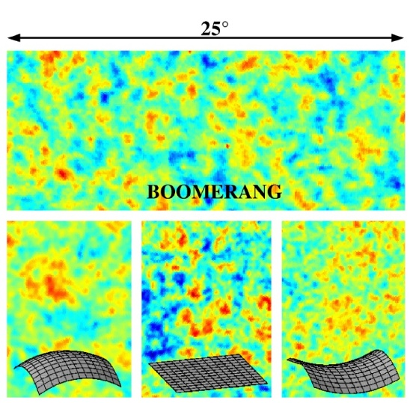
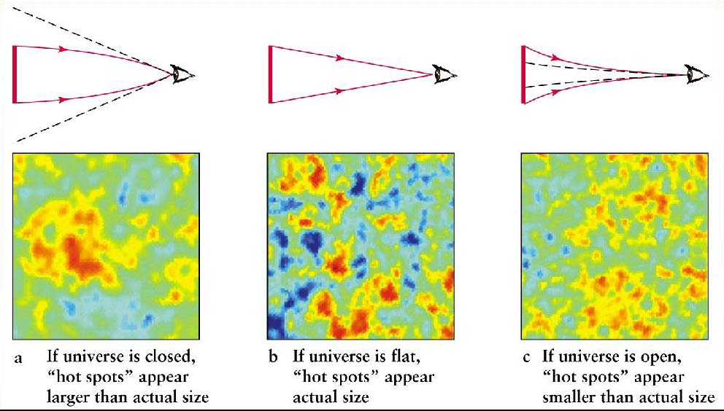

- The name ‘Big Bang’ suggests that it was a huge explosion like a water balloon popping or a firecracker exploding. Explain how these are not good models for how the universe started. Hint: Is matter expanding into existing space?
Student Answer: In an explosion matter and energy moving into already existing space. In the Big Bang, the space that the matter is already in expands.

- Watch “The Known Universe” http://www.youtube.com/watch?feature=endscreen&v=702kVrhOvL4&NR=1 from the Rubin Museum of Art and the American Museum of Natural History.
- What are the farthest and oldest things that we can detect?
Quasars and the cosmic background radiation.
- Astronomical research costs money. Astronomy used to be important because it helped people time their crops, find their way at sea and they used to believe in astrology. These aren’t important anymore. Why do people continue to fund astronomical research?

Teacher Information: This question is mainly here to stir up discussions about why we do science. Unlike fundamental physics, this is much less likely to have practical spinoffs. Rocket science might help us find and extract useful resources on the moon or nearby planets. It also has led to satellite technology (better weather predictions, GPS, global communications etc.). It might help us ward off large meteors. But most of astronomy and astrophysics just use rocket science to further our understanding. This understanding is important because people are curious about why we are here and what ’here’ is.

