Evidence for Global Warming and its causes OTF-OAPT 2018

- PI: Temperatures are rising: Determining temperature on a global scale requires averaging thousands of local measurements. Climate scientists use computer programs called climate models to perform this calculation. Each model uses slightly different data sets and methodologies.
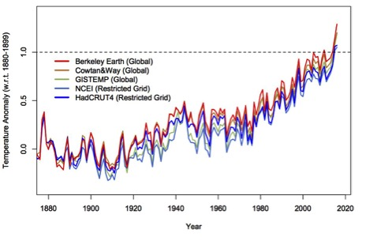

Is this data convincing? In what year would you have been convinced?

- Declining ice and snow:
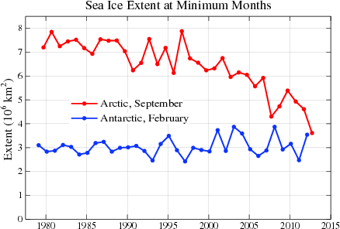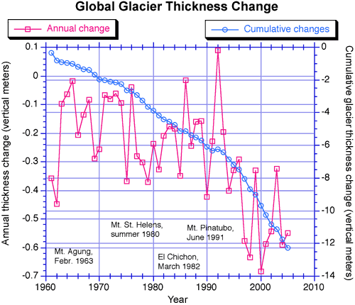
https://nca2014.globalchange.gov/report/our-changing-climate/melting-ice#intro-section-2
Image courtesy of Mark Dyurgerov, Institute of Arctic and Alpine Research, University of Colorado, Boulder.

- Look at the graph above left. Does it show evidence for global warming? Explain.

- Look at the graph above right. Does this show evidence for global warming?
- PI: Rising Sea Level:
- PI: A bottle is filled with water and then sealed with a one-holed rubber stopper. A tube is placed in the hole. The bottle is heated. What will happen to the water level in the tube? What effect will a warming ocean have on sea levels?

- PI: Two glasses hold water at the same level. One glass also contains rocks that are higher than the water level. Several ice cubes are placed in the water of one and on the rocks of the other. What will happen to the water level in each cup as the ice melts? What effect will melting ice have on sea levels?

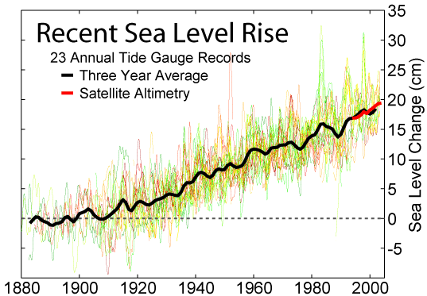
https://commons.wikimedia.org/wiki/File:Recent_Sea_Level_Rise.png

- Does this graph provide evidence of global warming? Alaska has declining sea levels. Does this disprove global warming?

- PI: A balloon is filled with air and another balloon is inflated to the same size, but is ¼ filled with water. A flame is held beneath each balloon. What will happen? This is a demonstration of the high heat capacity of water. What effect does this heat capacity have on global warming?

- Effect of the atmosphere: The Earth and the Moon are about the same distance from the Sun. However, the temperature of the Moon ranges from 100 º C in the daytime to -170º C at night! The Earth is protected from these extreme temperatures by its atmosphere. This process is often called the greenhouse effect. Go to https://phet.colorado.edu/en/simulation/legacy/greenhouse
- Describe what happens to visible light from the Sun. What will happen if you increase the number of clouds? What will be different if you switch from today to 1750? What will be different if you switch from today to the ice age?

- Go to http://kcvs.ca/site/projects/JS_files/Collisional_Heating/CollisionalHeating.html What is the effect of infrared light on the various gases?

- PI: What could be causing global warming? Examine the evidence cards for the six factors below. Which one or two factors are most likely responsible for global warming?
- aerosol pollution

- greenhouse gases

- land use changes

- ozone depletion

- solar variation

- volcanic eruptions

- One of the key greenhouse gases is carbon dioxide. It is hard to imagine that human activities can affect the whole Earth, especially when we know that carbon dioxide levels and climate have changed many times in the past. Are the recent changes part of this normal variation?
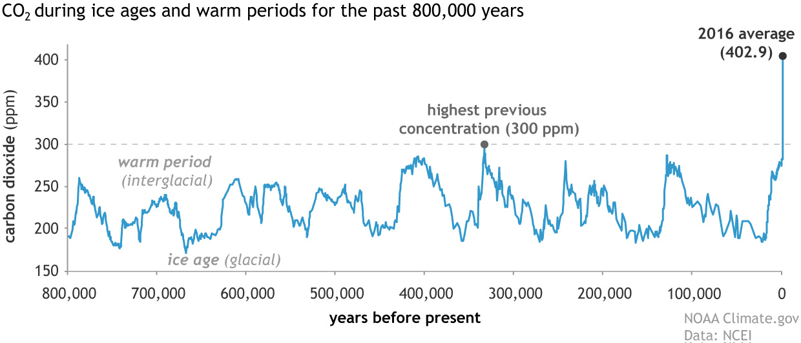

- Where does this extra carbon dioxide come from? The amount of carbon on Earth is fixed. The carbon cycle describes how carbon moves around in different forms, but the total amount of carbon does not change. Carbon spends time in the atmosphere as carbon dioxide, in the biosphere as organic matter, in the hydrosphere as carbonates, and in the lithosphere as fossil fuels.
Where is carbon decreasing?
- Atmosphere B) biosphere C) lithosphere D) hydrosphere

- PI: How do these graphs suggest that the increased carbon dioxide is due to human activities?
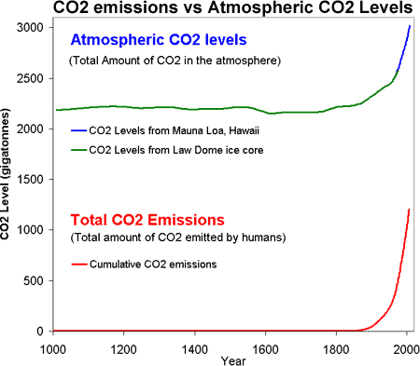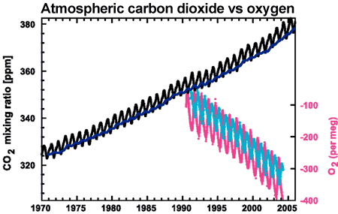
CO₂ concentrations from Mauna Loa, Hawaii and Baring Head, New Zealand (long line)and atmospheric oxygen measurements from Alert, Canada and Cape Grim, Australia (short lines) (IPCC AR4 2.3.1 adapted from Manning 2006).

