Evidence for Global Warming and its causes OTF-OAPT 2018
This problem used to be called global warming, but has since changed because it involves so much more than warming. I have chosen to start with the simpler early problem and use it to lead into the concept of climate change.
- PI: Temperatures are rising: Determining temperature on a global scale requires averaging thousands of local measurements. Climate scientists use computer programs called climate models to perform this calculation. Each model uses slightly different data sets and methodologies.
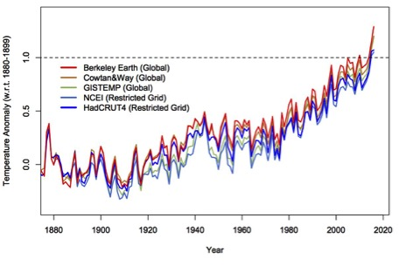

Is this data convincing? In what year would you have been convinced?
Scientists have been warning about the problem and predicting this for half a century. However it wasn’t obvious to other people that their models and predictions were correct and so little was done. People need to know that the facts are in now, the scientists were right and we need to do something before it is too late.
- Declining ice and snow:
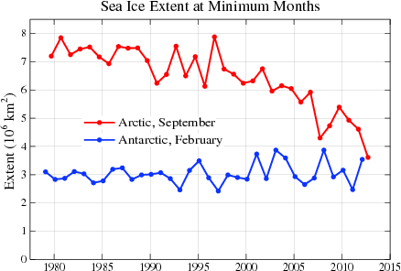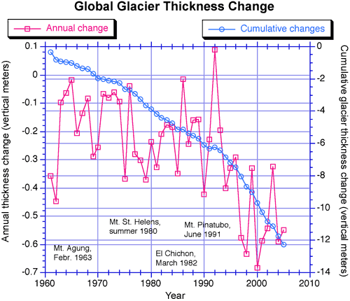
https://nca2014.globalchange.gov/report/our-changing-climate/melting-ice#intro-section-2
Image courtesy of Mark Dyurgerov, Institute of Arctic and Alpine Research, University of Colorado, Boulder.

- Look at the graph above left. Does it show evidence for global warming? Explain.
The Antarctic appears to show no change. This does not disprove global warming – but it can be used this way by deniers. It is important to look at global changes, because local variations can go against the trend.

- Look at the graph above right. Does this show evidence for global warming?
This shows clear a clear decrease in glacier thickness. The cumulative data shows it more clearly. At a casual glance it looks like the annual change varies a lot. It does! However, if you look at the scale you can see that the change is always negative.

- PI: Rising Sea Level:
- PI: A bottle is filled with water and then sealed with a one-holed rubber stopper. A tube is placed in the hole. The bottle is heated. What will happen to the water level in the tube? What effect will a warming ocean have on sea levels?
Most students predict the results correctly. The change happens within seconds. For clear results, use a bottle with stiff sides that won’t expand to allow more room for the liquid. This is one reason why global sea levels should rise.

- PI: Two glasses hold water at the same level. One glass also contains rocks that are higher than the water level. Several ice cubes are placed in the water of one and on the rocks of the other. What will happen to the water level in each cup as the ice melts? What effect will melting ice have on sea levels?
Most students will predict the wrong effect of the melting ice cubes. This is a minor interesting point about density and buoyancy and is a minor point about climate change. The fact that melting icebergs will not cause the sea level to rise is not as important as the fact that melting glaciers and ice sheets will. Note: This takes ten minutes to show a clear change, so it is good to do the predictions early in the class and then come back to see the results.

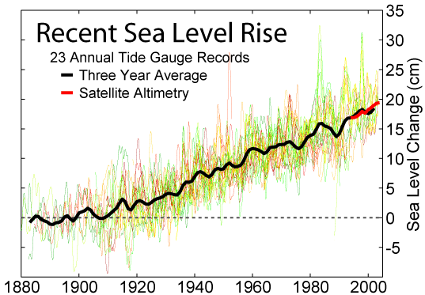
https://commons.wikimedia.org/wiki/File:Recent_Sea_Level_Rise.png

- Does this graph provide evidence of global warming? Alaska has declining sea levels. Does this disprove global warming?
Now that we understand that increasing temperatures will cause the sea level to rise for two reasons, an increase in sea level is evidence for global warming. The red line shows the new technology that is being introduced to monitor the change more thoroughly and precisely. The satellites record data from many more than 23 locations. This graph is another good example of how we need to look at data over time and over the whole globe. Alaska’s sea levels are declining because the land is rising. However, a climate change denier could cherry pick this data to ‘disprove’ climate change.

- PI: A balloon is filled with air and another balloon is inflated to the same size, but is ¼ filled with water. A flame is held beneath each balloon. What will happen? This is a demonstration of the high heat capacity of water. What effect does this heat capacity have on global warming?
This is a fun demo! Get the students to predict first and explain their predictions. Pop the balloon without water. This is fun but no surprise and then show how the water filled one can take the heat. Eventually, one student asks what will happen if you put the flame near the top of the balloon where there is no water? Collect predictions, hold the balloon over sink and try it. A messy explosion results.

- Effect of the atmosphere: The Earth and the Moon are about the same distance from the Sun. However, the temperature of the Moon ranges from 100 º C in the daytime to -170º C at night! The Earth is protected from these extreme temperatures by its atmosphere. This process is often called the greenhouse effect. Go to https://phet.colorado.edu/en/simulation/legacy/greenhouse
- Describe what happens to visible light from the Sun. What will happen if you increase the number of clouds? What will be different if you switch from today to 1750? What will be different if you switch from today to the ice age?
The greenhouse effect is really well understood and is the reason why life on Earth is possible. Most of the visible light passes though the atmosphere unaffected. It may reflect from snow or clouds and if it is absorbed by the ground it turns into infrared radiation which does not pass through the atmosphere easily. It is absorbed and reemitted in random directions. Eventually, it escapes to outer space. If you switch to 1750 and wait, it gets a bit cooler and the ice age a lot cooler with lots more light reflecting from the ground. Why? In each case there was less carbon dioxide in the atmosphere. I use this simulation with the full class predicting and observing but it could be turned into a small group investigation at many computers.

- Go to http://kcvs.ca/site/projects/JS_files/Collisional_Heating/CollisionalHeating.html What is the effect of infrared light on the various gases?
This simulation does a great job showing how the different molecules can absorb different types of light and vibrate in different ways. It is fun to imitate the motions. It connects the energy of the light with the EM spectrum. This ties in well with the light unit and the chemistry unit in grade 10.

- PI: What could be causing global warming? Examine the evidence cards for the six factors below. Which one or two factors are most likely responsible for global warming?
Climate change deniers may accept the fact of global warming but not accept that it is due to manmade causes. This activity gives students a chance to explore some of the other possible causes that are mentioned.

There are many ways that the cards can be used. The simplest way is to give the six cards to each group. Another way is to assign one of these to each group and they report to the class. It could be done as a jig saw.

Note: It may be a mistake to call these evidence cards. These are models and not observations.
- aerosol pollution
NO. This gives the opposite effect. More aerosols in the air will reflect light back to space and reduce not increase the warming. Pollution helps reduce global warming quite significantly. There have been suggestions that we should put light reflective particles high in the atmosphere to counter global warming.
- greenhouse gases
YES. No surprise here.
- land use changes
NO. Land use changes will alter the albedo – how reflective it is. Clearing forests for agriculture or cities tends to increase the amount of reflection and cause slight cooling.
- ozone depletion
YES. We know that ozone in the upper atmosphere absorbs dangerous uv and prevents it from reaching us. A lack of ozone will let this through and it will be absorbed by the ground and reradiated as ir. However, look at the scales of this graph and that for green house gases. There is a maximum change of 0.2º C for ozone depletion and 1.1º C for greenhouse gases. Furthermore, the ozone effect has started to reverse because of banning CFC’s.
- solar variation
NO? There might be a slight increase of 0.03º C. Maybe.
- volcanic eruptions
NO. This is the natural version of the man-made aerosol pollution. Volcanic activity causes a temporary decrease.

A nice summary https://www.bloomberg.com/graphics/2015-whats-warming-the-world

- One of the key greenhouse gases is carbon dioxide. It is hard to imagine that human activities can affect the whole Earth, especially when we know that carbon dioxide levels and climate have changed many times in the past. Are the recent changes part of this normal variation?
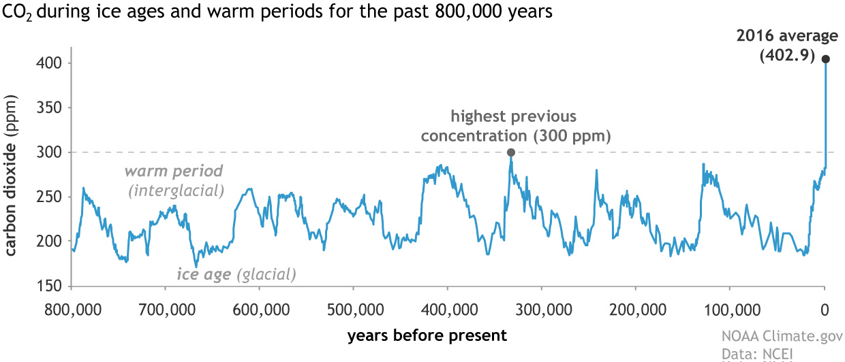

This graph shows that it is true that carbon dioxide levels have changed greatly in the past. It also shows that the recent change is not part of this standard variation.

This data comes from testing the gas in bubbles trapped in ice cores drilled kilometers down in the Arctic. The ice has yearly lines like tree rings.

The axis does not start at zero and this makes the effect more dramatic. However, it also looks ‘cheating’. You get the impression that carbon dioxide levels have doubled when they have ‘only’ increased by 50%. The effect would be just as clear if the graph started form zero.

- Where does this extra carbon dioxide come from? The amount of carbon on Earth is fixed. The carbon cycle describes how carbon moves around in different forms, but the total amount of carbon does not change. Carbon spends time in the atmosphere as carbon dioxide, in the biosphere as organic matter, in the hydrosphere as carbonates, and in the lithosphere as fossil fuels.
Where is carbon decreasing?
- atmosphere B) biosphere C) lithosphere D) hydrosphere
- and C). Forests are being clut down and fossil fuels are being burnt. The contribution from the lithosphere is much bigger.
- PI: How do these graphs suggest that the increased carbon dioxide is due to human activities?
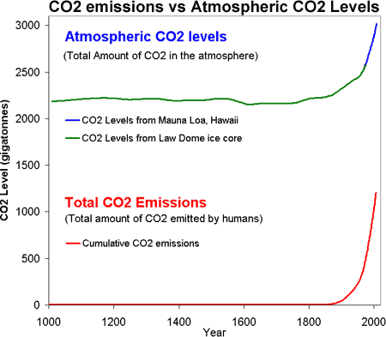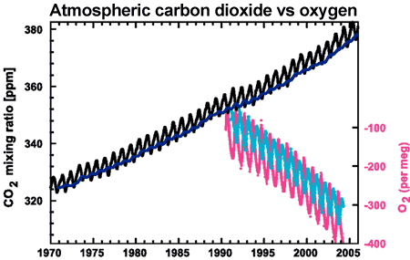
CO₂ concentrations from Mauna Loa, Hawaii and Baring Head, New Zealand (long line)and atmospheric oxygen measurements from Alert, Canada and Cape Grim, Australia (short lines) (IPCC AR4 2.3.1 adapted from Manning 2006).
The graph on the left shows a strong correlation between carbon dioxide emitted by humans and the atmospheric levels. The changes are not just n the same direction but they occur at the same time and by the same amounts. There is a simple mechanism (burning) to connect the two. This is not proof of causation – but getting really close. The graph on the right provides further evidence that the connection may be causal because burning requires that oxygen be used up.
Showing that global warming is caused by humans is similar to a criminal trial where the prosecutor is trying to prove that the accused murdered someone. You need evidence from a variety of sources. These graphs can be considered the ‘smoking gun’.
It is important to realize that global warming is also caused by other gases. However, it is perhaps clearer to focus on carbon dioxide – especially for grade-nine science.
Compound | Formula | Concentration in  atmosphere^{[25]}(ppm) | Contribution  (%)
Water vapor and clouds | H  ₂O | 10–50,000^{(A)} | 36–72%
Carbon dioxide | CO₂ | ~400 | 9–26%
Methane | CH  ₄ | ~1.8 | 4–9%
Ozone | O  ₃ | 2–8^{(B)} | 3–7%
https://en.wikipedia.org/wiki/Greenhouse_gas

