What are the effects of climate change and how can they be reduced? OTF-OAPT 2018
Global warming, caused by the greenhouse effect is expected to do much more than just raise temperatures. This is why scientists prefer to call the problem climate change.
- Rising Sea Levels: Scientists expect that sea level will rise by 0.50 m – 1.65 m by the year 2100.
- Why will local effects vary?

- Go to https://ss2.climatecentral.org/ What will happen if global sea levels rise by 1.5 m in Toronto and Vancouver? What cities outside of Canada will be most affected?

- Extreme weather: Warmer temperatures will increase the evaporation of water from soil, plants and water bodies. The atmosphere already holds 4% more water vapour than it did 40 years ago. This increased evaporation will increase the frequency and intensity of
- droughts, forest fires B) rainfall C) snowfall D) all four

- Extreme weather: Storm surges are the temporary raising of water level caused by low pressures during a storm. There are going to be more storm surges and flooding because of
- higher sea levels B) stronger winds C) heavier rainfall D) all three

- Extreme weather: Does this graph support the prediction of more extreme weather?
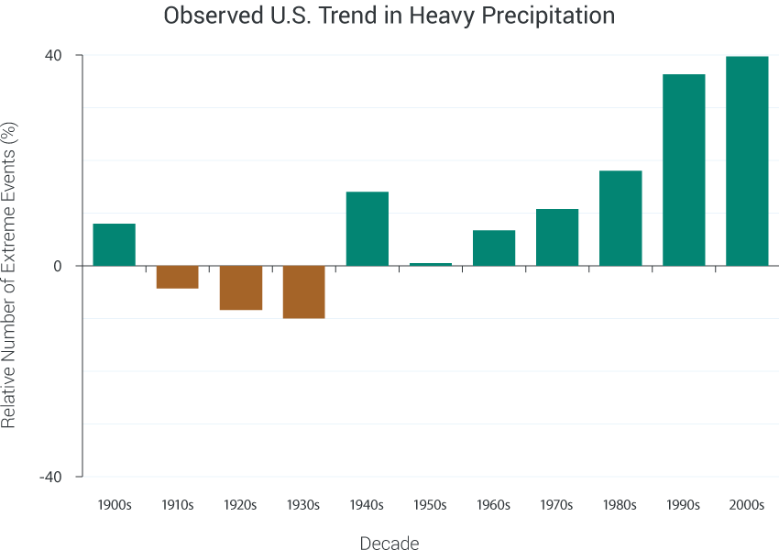
Adapted from Kunkel et al 2013

- Many effects of climate change form feedback loops that can accelerate or decelerate the changes. Which of the following will not speed up climate change?
- Melting permafrost releases methane.
- Melting snow and ice decreases reflection of sunlight.
- Warmer air causes more evaporation.
- Increased carbon dioxide in the atmosphere causes more carbon dioxide in the ocean.

- Increased carbon dioxide in the ocean has other effects.
- PI: Blow into a solution of Bromothymol blue. What happens? What will happen in the ocean?
- Put calcium carbonate (chalk) into vinegar. What happens? What will happen in the ocean?
- Warmer ocean surfaces make the water less dense and reduce upwelling. Therefore fewer nutrients reach the surface. This results in less phytoplankton, which are responsible for over half of the photosynthesis on the Earth. Does this form a feedback loop?

- Climate change will alter the atmospheric and ocean currents: How much of Europe is further north than Toronto? The Gulf Stream is driven by cold, salty water sinking in the Arctic. What will change?
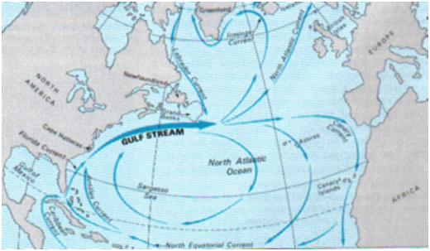http://www.robinsonlibrary.com/geography/oceanography/dynamics/gulf.htm
- There have been other global environmental problems. How has each of these been solved (mostly)?
- acid precipitation b) ozone depletion c) population explosion

- In the next 50 years, the carbon emitted is expected to double. What would it take to stop this growth?
www.explainingclimatechange.ca/Climate%20Change/javascript/Stabilization%20Wedges/stabilizationWedges.html
- Vehicle efficiency and use

- Buildings

- Decarbonization of power

- Agriculture

- PI: Transportation represents over 20% of Canada’s greenhouse gas emissions.
- An average car emits 250 g of carbon dioxide per km. An average Canadian travels 400 km by car each week. Suppose there is another person in the car. How much carbon does each emit per week?
- An average tree absorbs 50 g of carbon dioxide each week. How many trees are required to absorb this carbon dioxide?
- The effect of a trip by airplane is similar to driving it in a medium sized car alone. It is 4500 km from Toronto to Vancouver. How does one round trip compare to a week of driving?
- What would it cost to offset this? https://sustainabletravel.org/utilities/carbon-calculator/

