What are the effects of climate change and how can they be reduced? OTF-OAPT 2018
Global warming, caused by the greenhouse effect is expected to do much more than just raise temperatures. This is why scientists prefer to call the problem climate change.
- Rising Sea Levels: Scientists expect that sea level will rise by 0.50 m – 1.65 m by the year 2100.
- Why will local effects vary?
Prevailing winds, slope of land near the shore, whether the land itself is rising or falling.

- Go to https://ss2.climatecentral.org/ What will happen if global sea levels rise by 1.5 m in Toronto and Vancouver? What cities outside of Canada will be most affected?
There will be almost no effect on Toronto. A large part of Vancouver will be under water. Asian cities will be hardest hit (80% of people affected): i.e. Shanghai, Hong Kong, Osaka. Also Miami, The Hague, Alexandria, Rio de Janeiro.

- Extreme weather: Warmer temperatures will increase the evaporation of water from soil, plants and water bodies. The atmosphere already holds 4% more water vapour than it did 40 years ago. This increased evaporation will increase the frequency and intensity of
- droughts, forest fires B) rainfall C) snowfall D) all four
D) The evaporation will leave the land drier and will increase precipitation in winter and summer.

- Extreme weather: Storm surges are the temporary raising of water level caused by low pressures during a storm. There are going to be more storm surges and flooding because of
- higher sea levels B) stronger winds C) heavier rainfall D) all three
D)

- Extreme weather: Does this graph support the prediction of more extreme weather?
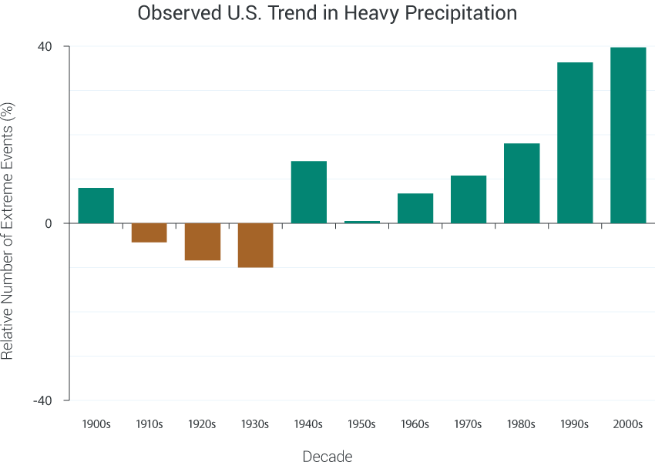
Adapted from Kunkel et al 2013
This graph is another example of how the scientists were predicting a problem but the evidence wasn’t clear until recently.

- Many effects of climate change form feedback loops that can accelerate or decelerate the changes. Which of the following will not speed up climate change?
- Melting permafrost releases methane.
- Melting snow and ice decreases reflection of sunlight.
- Warmer air causes more evaporation.
- Increased carbon dioxide in the atmosphere causes more carbon dioxide in the ocean.
D) Methane is another very potent greenhouse gas. Melting snow and ice will increase absorption of sunlight. Water is another greenhouse gas. The ocean has been protecting us by absorbing a lot of the carbon dioxide that would otherwise be in the atmosphere.
- Increased carbon dioxide in the ocean has other effects.
- PI: Blow into a solution of Bromothymol blue. What happens? What will happen in the ocean?
The carbon dioxide in your breath forms carbonic acid and the colour changes from blue to green to yellow as the pH decreases.
- Put calcium carbonate (chalk) into vinegar. What happens? What will happen in the ocean?
A more acidic ocean will dissolve shells and coral.
- Warmer ocean surfaces make the water less dense and reduce upwelling. Therefore fewer nutrients reach the surface. This results in less phytoplankton, which are responsible for over half of the photosynthesis on the Earth. Does this form a feedback loop?
Sinking cold, salty water pushes other water up. This is made more difficult if the surface water is less dense. Less photosynthesis means less carbon dioxide being pulled out of the atmosphere and this forms a feedback loop making the effect even worse.
- Climate change will alter the atmospheric and ocean currents: How much of Europe is further north than Toronto? The Gulf Stream is driven by cold, salty water sinking in the Arctic. What will change?
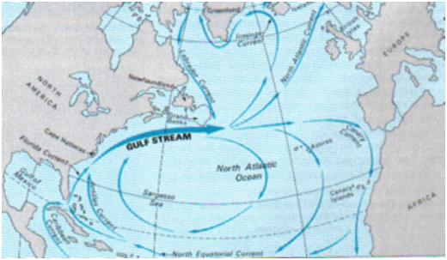http://www.robinsonlibrary.com/geography/oceanography/dynamics/gulf.htm
Most of Europe is north of Toronto! England and Scandinavia are at the latitude of Hudson’s Bay! Europe is much warmer at these latitudes because of the Gulf Stream. If the water becomes warmer and less salty (because of ice melting) it will not sink as strongly and so will not drive the Gulf Stream as well and Europe will get a lot colder. Notice that this increased cold is part of global warming.

- There have been other global environmental problems. How has each of these been solved (mostly)?
- acid precipitation b) ozone depletion c) population explosion
Acid Precipitation has been largely stopped by the development of catalytic convertors (that reduce nitrogen oxide emissions from cars) and scrubbers (that reduce sulfur oxide emissions from coal burning smokestack). This required internationally treaties and government policy to work – not individual goodwill.

Ozone Depletion has been stopped and the ozone holes are being repaired. This was the result of the development of new refrigerants, international treaties and governmental banning of CFC’s.

Population Explosion has been stopped because of reliable birth control technologies, reduced infant mortality and increased education and opportunities for women.

- In the next 50 years, the carbon emitted is expected to double. What would it take to stop this growth?
www.explainingclimatechange.ca/Climate%20Change/javascript/Stabilization%20Wedges/stabilizationWedges.html
- Vehicle efficiency and use
The simulation only lets you make changes that are realistic. There is no point in talking about having no cars.

Each aspect on its own has a certain effect but the combination of each results in an effect that is smaller than the sum of the separate effects because if you have fewer cars, then there are fewer cars to have their emissions reduced by being more efficient. However, the greatest reduction comes from maximizing all of the effects.

- Buildings
Making new buildings more efficient seems to have the greatest impact. We should do everything we can, but with limited resources, money and motivation – it is best to focus on the most effective techniques. This means you need to carefull study all of the possible changes and figure out which are most effective.

- Decarbonization of power
You can argue with some of their suggestions. They seem to be really dismissive of nuclear power and there may be a need for small reactors.

- Agriculture
Biofuels are carbon neutral. While the plants are growing they take in the carbon that is given out when the fuels are burnt. Biofuels should not replace food crops.

Conservation tillage has the potential to have a huge impact by sequestering carbon in the ground. It is being implemented in North America but it is not talked about much. Why? Instead of removing agricultural waste (stalks etc.) from and plowing the fields you just let this plant material form a layer that decomposes very little. This also means less driving around the fields burning fuel and the material helps retain water. On the downside it requires new, heavier machinery to be able to punch seeds into the ground and it requires more herbicides or GMO plants to control the weeds.

- PI: Transportation represents over 20% of Canada’s greenhouse gas emissions.
- An average car emits 250 g of carbon dioxide per km. An average Canadian travels 400 km by car each week. Suppose there is another person in the car. How much carbon does each emit per week?
250 * 400 * ½ = 50 000 g.
- An average tree absorbs 50 g of carbon dioxide each week. How many trees are required to absorb this carbon dioxide?
50,000/50 = 1,000 trees!
- The effect of a trip by airplane is similar to driving it in a medium sized car alone. It is 4500 km from Toronto to Vancouver. How does one round trip compare to a week of driving?
250 * 4500 * 2 = 2, 250,000 g 2250/50 = 45 weeks, almost a year of driving.
- What would it cost to offset this? https://sustainabletravel.org/utilities/carbon-calculator/
$40. If individual concerned people make a donation it will not help solve the problem. However, if the cost of an airplane ticket included this amount it could help fund a lot of good work and it would reduce some of these airplane flights.

