LUX android app measures light intensity both graphically and numerically making it ideal for exoplanet detection modelling

Kahoot (android and iOS)

Students love using their phones to review materials in preparation for final exams ( grade 9 and 10 )

Physics Toolbox sensors (android and iOS)

Amazing variety of sensors

1 Roller coaster records pressure (could be used to determine altitude), acceleration and g force

2. Barometer for grade 12 college physics very sensitive pressure detector

3. Light sensor similar to LUX

4. Accelerometers (place phone on cart on a ramp and measure linear accelerometer)
Drop phone onto a cushion to measure g

5. Inclinometer will measure the slope of the ramp

6. Proximity meter could be used to measure pendulum period

7. Sound intensity measures sound in dB versus time

8. Oscilloscope great for visualizing sound

9. Tone generator produces specific sounds ( two students set to slightly different frequencies for beats)

10. Stroboscope for motion diagrams

Google Classroom (android and iOS)

Communication tool for your classes (Edmodo is very similar)

Brain it On (android and iOS)

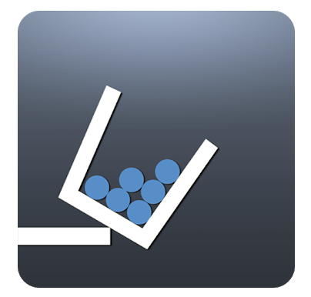
A game that requires students to solve physical puzzles. (at right we see dropping balls in the cup so that it falls off the ledge)

