Student Activity 2
Applications of Sound Waves
Part 1: Surveying the Sea Floor
The first surveys of the sea floor involved lowering a weighted rope down to the bottom, marking the top of the rope, and hauling it back to the surface to measure the ocean’s depth.
1. Form a group of three or four. Your teacher will provide you with a box, which represents the sea, and a string with a mass. Your group will make a profile of the sea floor using this traditional method.
2. Lower the mass beside the box so the string is taut, and measure the height of the box as shown below. Make a mark on the string indicating the depth of the box. This is your reference level.
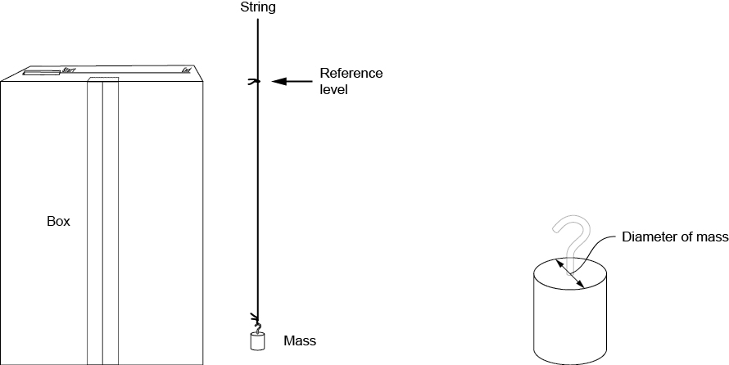
(a) (b)
The box and string showing (a) how to mark the reference level and (b) where to measure the diameter of the mass (right).
3. Measure the diameter of the mass on the end of the string. Mass diameter: _______________.
4. To make the profile, you will be dropping the line and measuring the depth at locations spaced out by the diameter of the mass. Why do you think this is necessary? How does the diameter of the mass affect the precision of the measurements?

5. Along the top of the box, mark the measurement locations. The spacing between the marks should be the same as the diameter of the mass.
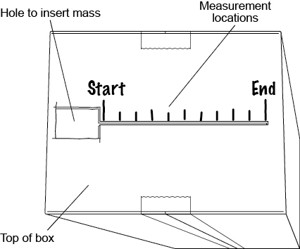
Top of box showing where to insert the mass and where to make measurements
6. Start at the side of the slit closest to the cut-out hole. Insert the mass in the hole, holding the string, and slide it to the first marked position. Lower the mass until it does not go down any more. Measure the length of string between the top of the box and the reference level. Repeat the measurements at each marked position and use them to create a bar chart on the chart paper below. The widths of the bars should match the diameter of the mass. The bar chart represents your “seabed” profile.
7. Examine the bar charts made by other groups. Which groups were able to make the most detailed profiles? How could your group make a more detailed profile? Explain.

8. Open the box and examine the profile you were measuring. Evaluate the quality of your sketch. Did you miss any features? What is the relationship between the diameter of the mass and the level of detail of your sketch?
9. Over time, the number of pixels per cm2 on television screens and computer monitors has increased. Based on what you have learned, explain why this would lead to a sharper, higher-resolution, image.
Part 2: SONAR
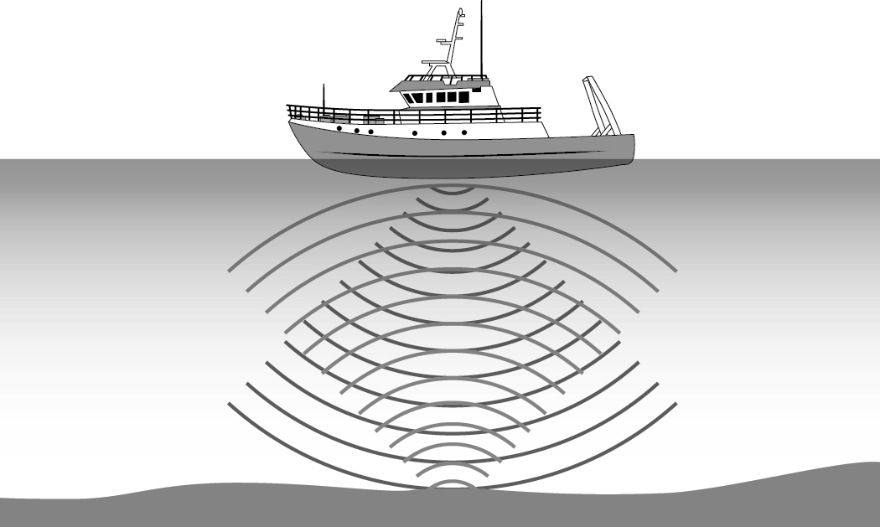
SONAR measures the depth of the ocean using sound waves.
In the early 1900s, SONAR was developed to map the ocean floor using sound waves. A SONAR transducer sends out “pings,” which travel through the water and reflect off the seabed as echoes. These are then recorded by a receiver. Knowing the speed of sound in seawater (vsw), and using the time between sending the “ping” and receiving the echo (∆t), oceanographers can measure the depth of the sea.
1. In your group, determine the equation to calculate the depth of the seabed in terms of vsw and ∆t.
2. In Part 1, you used masses of different diameters to map a model of the sea floor. Based on what you learned in Part 1, if you wanted to make the most detailed map possible, would you choose Wave 1 or Wave 2 below? Support your choice.
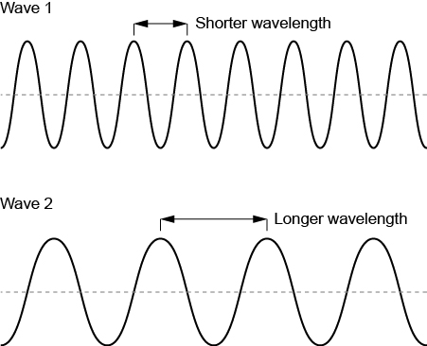

3. (a) SONAR uses sound waves with frequencies between 50 kHz and 600 kHz, called ultrasound. The speed of sound in seawater is approximately 1500 m/s. Calculate the wavelength range of ultrasound pulses used in SONAR.
(b) Why would SONAR rely on such high frequencies?
(c) SONAR can detect objects as small as half a wavelength in size. Which frequency of SONAR would provide the most detailed seafloor map?
(d) Estimate the size of the smallest object that SONAR can detect.
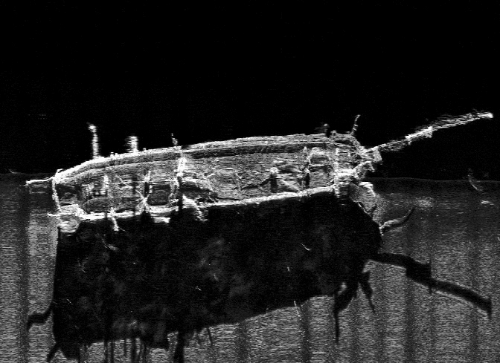
Credit: © PARKS CANADA
Side-scan SONAR image of HMS Terror found in Nunavut’s Terror Bay. The ship sank in 1848 during the Franklin expedition and, with the aid of Inuit traditional knowledge, was found in 2016 using SONAR.
4. SONAR is used not only to map the sea floor but also to find objects like shipwrecks. Brainstorm with your group other possible uses of SONAR, and list three of them.
5. The hearing ranges of aquatic animals are shown on the right. Classify the animals in terms of whether or not they can hear SONAR. How might these animals be affected by the use of SONAR?
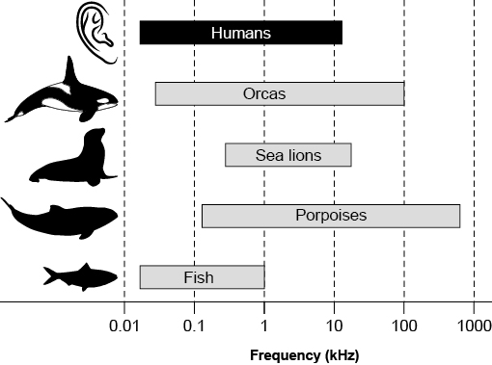
Hearing ranges of various aquatic animals and humans shown on a logarithmic scale

Part 3: Medical Ultrasound Imaging
Much like SONAR, ultrasound imaging uses sound waves to determine the distances to surfaces. In this case, however, the surfaces are the edges of organs, tumours, or bone.
1. You are an ultrasound technician assessing a patient’s kidney. The average distance from the skin to the kidney in adults is 6 cm. Human tissue is made mostly of water. Determine the time interval between sending out the pulse and receiving the echo.
2. An average kidney is approximately 10 cm across. Based on what you learned in Part 2, what is the minimum frequency required to detect surface abnormalities as small as 1 mm on a kidney?
3. In your group, discuss the pros and cons of ultrasound imaging compared to other techniques used to see inside the body, such as X-rays, scopes, and surgery. When would you choose to use these diagnostic techniques and why?
Consolidate Your Learning
Answer the following questions to check your understanding of applications of sound waves.
Bats hunt for insects at night. How do they detect their prey in the dark? They use a similar technique to SONAR and ultrasound imaging, called echolocation. Unlike humans, bats can hear frequencies as high as 200 kHz. They send out ultrasonic “chirps” and listen for the echoes. Echoes allow them to infer the distance to different objects.
1. Why would bats use high-frequency rather than low-frequency sounds for echolocation?
2. If a typical moth is 2 cm long, what is the minimum frequency a bat would need to use to detect it? Assume the speed of sound in air is 343 m/s.
3. A bat emits a 50.0 kHz pulse in air. It receives an echo 0.300 s later, revealing the location of a moth at rest on a plant. Mark along the line where the bat should strike.
