Student Activity 1
Wave Interference
Part 1: Modelling Waves
1. Eight students will transmit a signal along a line. Sketch the pattern made by the signal. Label the wavelength, amplitude, and direction of propagation of this transverse wave.
2. Explain what happens to the wave when it meets its reflection. Sketch the resulting pattern and describe why this pattern is called a standing wave.
3. What rules did you follow when combining two instructions at the same time? Complete the following table.
Combining Displacements | +1 | −1 | 0
+1
−1
0
Part 2: Modelling Superposition
Superposition is a fundamental property of waves. Each particle in the medium that carries the wave can be in only one place. Wave displacements are added, and the medium moves according to the total displacement.
1. Form a group of two or three. Take two wave transparencies. Identify the wavelength and amplitude of the waves.
2. Sketch the resultant wave if the two waves overlap perfectly.
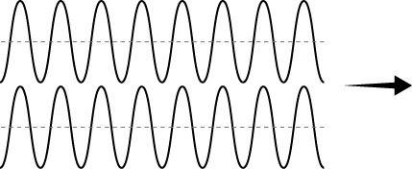
3. Slide one wave one full wavelength to the right. Sketch the resultant wave. What do you notice?
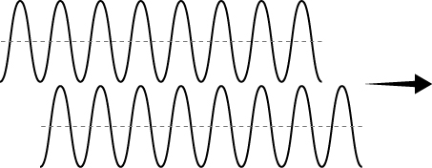
4. Slide one wave only half a wavelength to the right. Sketch the resultant wave. What do you notice?
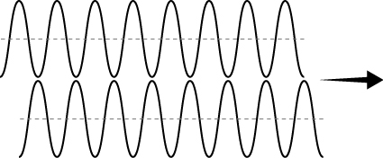
5. Flip one wave vertically (top to bottom). Sketch the resultant wave. What do you notice?
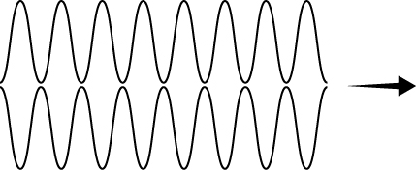
6. Constructive interference describes a resultant displacement that is greater than the original. In which of the previous steps did the waves produce constructive interference? What conditions are needed for constructive interference?
7. Destructive interference describes a resultant displacement that is smaller than the original. In which of the previous steps did the waves produce destructive interference? What conditions are needed for destructive interference?

Part 3: Using Interference
1. In your group, identify situations where it would be beneficial to reduce the amplitude of a wave.
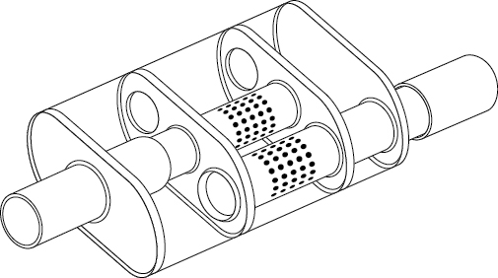
Car mufflers use interference.
2. Sound is modelled as a wave. Car engines generate loud sounds. Use the diagram on the right to infer how a muffler causes interference to reduce the amount of noise produced by cars. What is the essential action that must happen for the sound waves to cancel each other out?
3. Noise-cancelling headphones have a built-in microphone that records ambient noise. Use what you know about interference to design noise-cancelling headphones. Explain how your design meets the essential action that must happen for the headphones to cancel ambient sound.
Why does the intensity of sound change?
4. Two speakers continuously emit the same sound. If you walk back and forth parallel to the speakers, you’ll notice that the sound changes as you walk. Describe the pattern you observe, and explain why it is happening.

Consolidate Your Learning
Answer the following questions to check your understanding of wave interference.
1. What conditions are needed for destructive interference? What are two ways to create these conditions?
2. Sound is a longitudinal wave. Describe what happens to the air particles in a tube when two identical sound waves pass through it, going in opposite directions.
3. Imagine that you are in a small fishing boat on the ocean when two weather patterns collide. Explain why this would be a potentially hazardous situation.
4. Noise-cancelling headphones are effective at cancelling ambient noise for one person. Is it possible to apply the same principles on a larger scale to cancel the noise in the cafeteria? Explore the field of acoustic engineering to discover what can be done to reduce noise in large crowded spaces.

