Student Activity 6
Where Do the Elements Come From?
Part 1: Modelling Nuclear Fusion in Stars
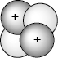
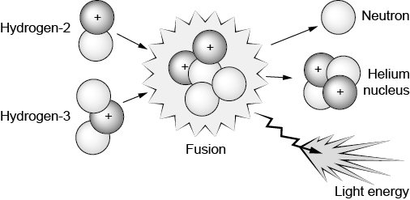
Inside the Sun, hydrogen nuclei collide with each other. These collisions can sometimes lead to fusion, which produces a helium nucleus and releases energy as described by the following reaction equation:
$${}_{1}^{2}H+ {}_{1}^{3}H {}_{2}^{4}{He}+ {}_{0}^{1}n+light energy$$
1. Examine this sketch of a helium nucleus. Given
that like charges repel, speculate why protons
in the helium nucleus stay together.
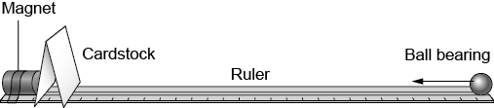
2. Your teacher will provide you with a magnet, a ruler, a ball bearing, and cardstock. Set them up as shown. Gently tap the ball bearing so it begins to roll toward the cardstock. Observe and explain what happens.
3. Roll the ball bearing again, but this time try to make it strike the magnet. What do you need to do for this to happen?
4. The ball bearing and magnet are an analogy for two fusing hydrogen nuclei. The cardstock is an analogy for the electric repulsive force between them. The magnetic force is an analogy for an attractive, short-range interaction force called the strong force, which holds nucleons together when they get very close (less than 10–15 m apart). Using the model, qualitatively explain the conditions under which nuclear fusion proceeds and helium nuclei form.

5. A star like our Sun has a tremendous mass of 2 × 1030 kg. This high mass compresses the core to a temperature of 15 million degrees Celsius. Describe what happens to the kinetic energy of the atoms in a gas when the temperature increases. Explain why nuclear fusion reactions occur only when temperatures are sufficiently high.
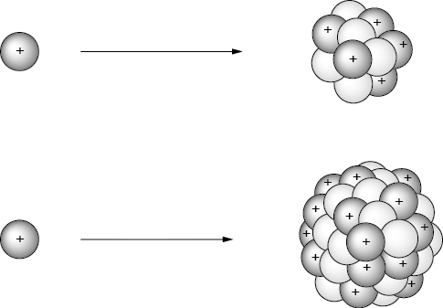
6. Examine a proton approaching two different nuclei. Explain whether the electric repulsive force between the proton and the nucleus will increase, decrease, or stay the same as the number of nucleons increases. Explain whether the temperature will need to be higher, be lower, or stay the same for fusion to proceed.
Part 2: Making the Elements
Hydrogen, helium, and trace amounts of lithium, beryllium, and boron were created during the Big Bang. All other elements are created by stars.
1. Your teacher will provide you with a set of Star Cards, which describe different stars in the universe. Order the Star Cards from lowest to highest core temperature. What do you notice about the elements that each star produces? Complete the following sentence by circling the correct term:
Stars with higher core temperatures can fuse heavier/lighter elements. Explain why.
2. Examine the masses of the stars ordered based on temperature. Complete the sentence by circling the correct term:
More massive stars have higher/lower core temperatures. Explain why.
3. How does a star’s mass determine which elements it can produce?

4. Examine the objects set out by your teacher. Identify the type of stars needed to produce the elements in the objects.
Object | Elements | Type of Stars
Bone | Calcium
Air | Oxygen, nitrogen
Water | Hydrogen, oxygen
Clay pot | Silicon, oxygen
Salt | Sodium, chlorine
Pencil lead | Carbon
Pie plate | Aluminum
5. The human body is made up of 65% oxygen; 18% carbon; 10% hydrogen; 3% nitrogen; and 8% other elements, including calcium, phosphorus, and potassium. Which types of stars created the atoms in your body?
Part 3: Iron Peak and Heavy Elements
Stars fuse lighter atoms together to make heavier ones. But not all elements are made in the cores of stars.
1. Compare the elements from Part 2, question 4 to the periodic table. Which elements are produced in stellar cores?
2. Examine the card with the most massive star and the highest core temperature. What is the heaviest element that is produced? How many protons are in the nucleus?
3. Based on what you know about electric repulsion, speculate on why stars don’t fuse elements heavier than this.
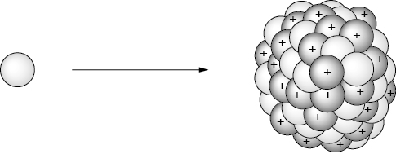
4. Examine this sketch of a neutron approaching a nucleus. Describe the electric repulsive force on the neutron.

5. Elements heavier than iron are not formed via fusion reactions in stellar cores. Heavier elements can form by slowly adding neutrons to the nucleus. This forms an unstable nucleus, which undergoes beta decay.
$${}_{0}^{1}n {}_{1}^{1}p+ {}_{–1}^{0}e+ {}_{0}^{0}{\overline{v}}$$
Beta Decay
This process of forming elements happens in shells surrounding the cores of intermediate-mass stars late in their lives.
(a) Consider iron-56. How many neutrons need to be added to make cobalt-59?
(b) Outline the steps needed to go from iron to cobalt.
6. To form the heaviest elements, many neutrons must be rapidly captured by the seed nuclei. This requires a high density of free neutrons.
(a) Consider gold-159. How many neutrons must be added to form gold-159 from iron-56?
(b) Why would neutrons need to be rapidly captured to form the heaviest elements?
(c) Consider the types of stars and stellar life cycle events you learned about in previous courses. Speculate where in the universe the energies would be sufficient to lead to high densities of free neutrons.

Consolidate Your Learning
Answer the following questions to check your understanding of the origin of the elements.
1. Nuclear fusion reactions are very difficult to achieve on Earth. Explain why.
2. Cosmologist Carl Sagan wrote, “The nitrogen in our DNA, the calcium in our teeth, the iron in our blood, the carbon in our apple pies were made in the interiors of collapsing stars. We are made of starstuff.” What did he mean?
3. If the elements are made inside stars, how did they get out to make Earth and everything on it?
4. Precious metals, such as gold, silver, and platinum, are rare and are some of the heaviest elements found on Earth. Consider the origin of these elements. What makes them rare and heavy?

