Student Activity 1
The Conservation and Transformation of Energy
Science Background
Consider converting money. You can convert between different currencies, but the value of the money is unchanged. For instance, you could have 650 Canadian dollars, or 500 US dollars, or 53 000 Japanese yen. Although these are different amounts, the value is the same. Similarly, energy can transform between different types, but the amount remains the same. In this activity, you will analyze the different ways we can store energy and investigate how energy is transformed into different types of storage.
Part 1: The Idea of Energy
1. Consider dropping a ball straight down from your right hand to your left. Define moment 1, t1, to be the instant the ball is fully released and moment 2, t2, to be the instant the ball first makes contact with your left hand. Describe how the velocity of the ball changes in the time interval Δt1:2.
2. You may recall that a moving object has energy due to its motion. Energy stored this way is called kinetic energy (Ek). How is the kinetic energy of the ball at t1 different from the kinetic energy of the ball at t2? What could you measure to track this difference for the ball?
3. There is another mechanism of energy storage in this process. It’s an energy store that is decreasing during the time interval Δt1:2. What other property of the ball decreased between t1 and t2? What name and label would you give this energy store?

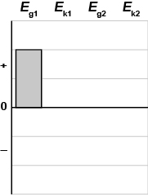
4. Historically, this energy store has been called gravitational potential energy (Eg). It isn’t stored in the motion of the ball. Instead it’s stored in the gravitational interaction between the ball and Earth’s gravitational field. The greater the separation between Earth and the ball, the greater the amount of energy stored. We will call it gravitational energy. Complete the chart on the right to track how the gravitational energy at moments 1 and 2 (Eg1 and Eg2) compares to the kinetic energy at moments 1 and 2 (Ek1 and Ek2). Justify your representation of the bars.
Energy can flow from one object to another. Energy can transfer from one type of storage mechanism to another. These ideas are an important part of analyzing and understanding energy because it is during these flows and transfers that interesting physics happens.
5. At moment 1, we know energy is stored as gravitational energy, Eg1, by the ball in Earth’s gravitational field. What happened before moment 1? Where did this amount of energy come from? (To simplify, you can abbreviate Earth’s gravitational field to Earth.)
6. Grouping objects into a system makes energy analyses easier because energy is often stored in the interactions between objects. For the time interval Δt1:2, explain why it’s simpler to choose the ball and Earth as the system for analysis rather than including the right hand from before t1.
7. Some time after moment 2, the ball comes to rest in the left hand. This is moment 3, t3. We know at t3 that the energy is no longer stored in the motion of the ball as kinetic energy. Where is this energy stored now? What property of the hand changed between t2 and t3? What about the ball?
The concept that energy cannot be created or destroyed is called “the conservation of energy.” “Cannot be created” means energy can’t appear out of nowhere. “Cannot be destroyed” means energy doesn’t disappear; instead it must go somewhere.

8. Fill in the table.
Examples of Energy Storage
Type of Storage | Name of Energy | Label | Storage Mechanism | Measured Property
Motion energy | Kinetic energy | Ek
 | Thermal energy | Eth | Stored in molecular and atomic motion
Interaction  (potential) energy | Gravitational energy | Eg | Stored in interaction between object and Earth (Earth’s gravitational field)
 | Elastic energy | Ee | Macroscopic: stored in stretch or compression of object (shape change)  Microscopic: stored in deformation of intermolecular bonds due to interactions between molecules
 | Chemical energy | Eint | Stored in interactions between particles
Part 2: Energy Flow Diagrams
To visualize how energy is stored and flows, use an energy flow diagram. Draw a circle around objects you choose as your system. Objects outside the system are called the environment. Draw arrows to show the transfers. When energy enters or leaves the system, this change is called work. You can represent work with an arrow entering or leaving the system.
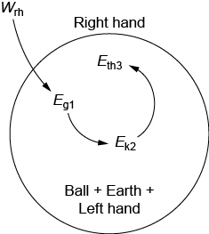
1. An energy flow diagram for the falling-ball example in Part 1 is shown at the right. Explain what is happening at each arrow and label, for example, Wrh Eg1.
2. Which objects did we define as the system, and which objects did we define as the environment?
Is energy flowing into or out of the system? How does the energy stored in the system change from moment to moment?
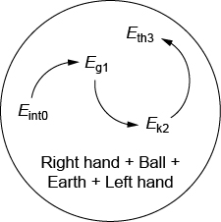
3. Consider moment 0, t0, a time before t1, where the ball was at rest and level with your left hand. For the time interval Δt0:3, we could have chosen the right hand to be part of our system. Qualitatively explain how Eg1, Ek2, and Eth3 would change. What other comparisons can you make with the previous energy flow diagram? How do you know if energy has been conserved for this system?
Part 3: Ramping Up
Examine the system set up by your teacher, which includes the cart, the spring, and Earth. There are three important events: (1) the spring is triggered, (2) the spring is fully expanded, and (3) the cart reaches its highest point on the track.
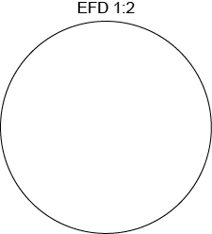
1. Assume the kinetic frictional interaction between the wheels and the track is negligible. Draw an energy flow diagram between moments 1 and 2 only. Describe any energy transfers or flows.
2. A student states, “I think energy is flowing from the cart to the track between moments 2 and 3.” Do you agree or disagree? What property of the system might support or refute this statement?
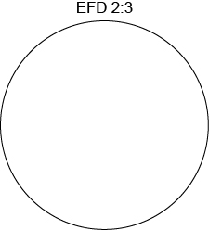
3. Draw an energy flow diagram for Δt2:3. Describe any energy transfers or flows.
A work-energy bar chart shows the amount of energy stored in each mechanism (gravitational, kinetic, elastic, etc.) of the system objects at two different moments in time. The precise height of the bars is not important, as long as the comparisons between the bars are clear. The shaded column in the chart, Wext, represents the energy flow into, or out of, the system.
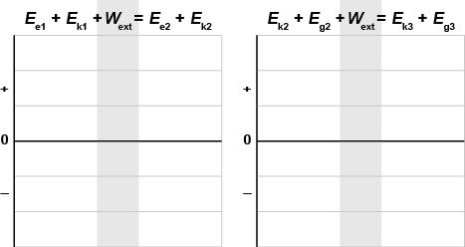
4. Draw a work-energy bar chart, like the one you made in Part 1, for the system between moments 1 and 2. Draw a separate work-energy bar chart for time interval Δt2:3. What is assumed about the amount of gravitational energy at moments 1 and 2?

Consolidate Your Learning
Answer the following questions to check your understanding of the conservation and transformation of energy, using energy flow diagrams and work-energy bar charts.
1. Continue your analysis of the cart on the ramp by considering what happens when the cart returns back to the bottom of the incline, just as the spring comes into contact with the barrier. This is moment 4.
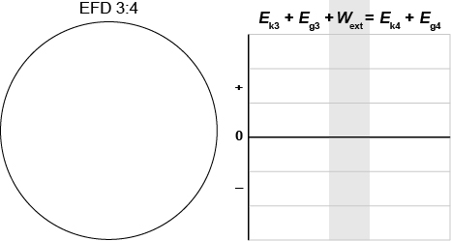
(a) Draw an energy flow diagram and a work-energy bar chart between moments 3 and 4.
(b) Using your diagram, how will the speed of the cart at moment 4 compare to that at moment 2? Explain your prediction using energy flow and energy transfer ideas.
(c) Draw an energy flow diagram between moments 1 and 4.
2. Test your prediction using the cart and ramp setup. Do your observations confirm your predictions? Explain.
3. In Part 1, you considered dropping a ball from your right hand to your left hand. Now, consider dropping an unfolded piece of paper instead. Define a system and the key moments for this situation. Draw an energy flow diagram. Describe what is happening in terms of energy flows and transfers.

