Three Models of Light

Light shows up in many different strands of science. For example, consider grade-9 science. Understanding light is essential for astronomy because it makes up over 99% of our observations. Light also makes a strong appearance in electricity (efficient lighting, solar cells and light detectors), chemistry (atomic spectra) and ecosystems (photosynthesis). Students may find light confusing because it is modelled in three very different ways; rays, waves and photons. What is the evidence for each model and how do they fit together?

Ray Model (grade 10 science)

- Light Beams
a) A laser pointer is shone on a wall and you can see a dot of light. Why can you see the spot but you can’t see anything between the pointer and the spot? Sketch your ideas on the white board.

b) How can the beam be made visible? Draw this on the white board.

- Pinhole Cameras:
- Label the parts of the pin-hole camera, shown in cross-section below.

- Look through the open end at some light sources. Describe what you see.

- Add light rays to the diagram above to explain how an image forms.

- What happens if the pinhole is made bigger? Add a second set of rays to explain.

Wave Model (grade 12)
- Diffraction:
- You have two pencils held together with elastics with a slight gap in between. You look through the vertical gap at a laser spot. What will it look like as the gap is squeezed?
- unchanged B) thinner C) wider D) it depends

Explain:

- Watch Waves https://www.youtube.com/watch?v=IZgYswtwlT8 (½ minute) and
Apertures and Diffraction https://www.youtube.com/watch?v=BH0NfVUTWG4 (2½ m)
We usually don’t notice diffraction because light
- has very small wavelengths B) has very big wavelengths
- travels very fast D) travels very slowly
Explain:

- How does the ray model fit with the wave model of light?
http://phet.colorado.edu/en/simulation/legacy/wave-interference

- Interference:
- Light is shone through two narrow slits, close together. What will you see on a distant screen?
- nothing B) one dot C) two dots D) many dots

- Use the transparencies and PhET simulation to explain what happened.

- What will happen if green light is used instead of red? The dots will be
- closer together B) farther apart C) brighter D) dimmer

Explain:
Quantum Model (grade 12)
- Wave-Particle Duality:
- Watch Double-slit interference buildup https://www.youtube.com/watch?v=H11hJWIcUY0&feature=youtu.be (1:00 – 1:44)
This shows that light is a
A) wave B) particle C) both D) neither

- Watch Single electron double slit wave experiment http://www.youtube.com/watch?v=ZJ-0PBRuthc Watch Single Molecules in a Quantum Movie http://www.youtube.com/watch?v=vCiOMQIRU7I&feature=player_embedded using phthalocyanine - C₃₂ H₁₈ N₈.
This shows that electrons and molecules are
- waves B) particles C) photons D) quantum objects

- Pair Creation and Annihilation: The rules of quantum physics don’t seem to make sense. However, the mathematics works really well and it has brought us computers, lasers, solar cells and Positron Emission Tomography (PET). PET is a medical scan that allows us to see biochemical activity in living organisms. The patient ingests a radioactive tracer attached to glucose which moves to wherever glucose is being used. The tracer emits a positron (the anti-matter equivalent of an electron) which annihilates when it meets an electron. The mass of the particles is turned into the energy of two photons. These move off in opposite directions to conserve momentum. The dark circles show where one pair of photons arrived at the detector. The grey circles show where a second pair arrived a bit later.
- Use these two pairs to determine where the radioactive glucose was being used.
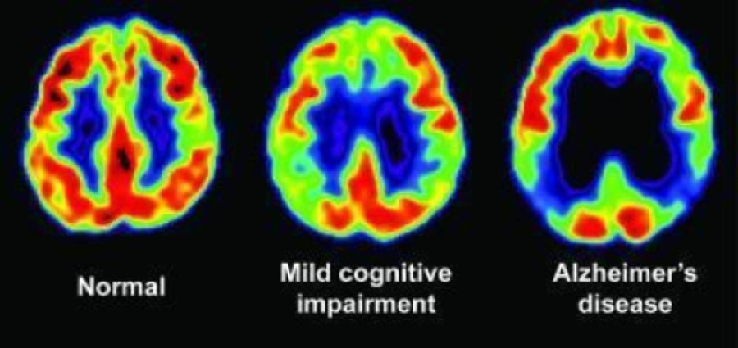 https://www.sciencedaily.com/releases/2009/07/090714085812.htm
- Is light behaving like a wave or a particle in a PET scan?

