Purpose: To measure the reaction speed to various stimuli (visual, auditory and tactile)

Materials: 30cm ruler, blindfold
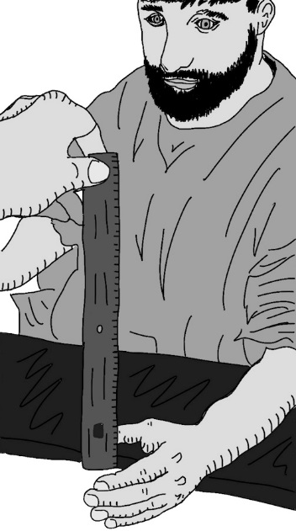
Visual Test
- Subject A dangles dominant hand off the edge of a table.
- Subject B holds a 30 centimeter ruler between two fingers at the 30 cm mark, having the 0 mark touching Subject A’s index finger.
- Subject B tells Subject A to grab the ruler as fast as possible, when they SEE it being released.
- Record the centimeter measurement.
- Repeat this three times, for a total of four measurements.

Auditory Test
- Subject A is blindfolded before dangling dominant hand off the edge of a table.
- Subject B holds a 30 centimeter ruler between two fingers at the 30 cm mark, having the 0 mark touching Subject A’s index finger.
- Subject B tells Subject A to grab the ruler as fast as possible, when they HEAR the word “GO” being said.
- Subject B simultaneously says “GO” and lets go of the ruler. Record the centimeter measurement.
- Repeat this three times, for a total of four measurements.

Tactile Test
- Subject A is blindfolded before dangling dominant hand off the edge of a table.
- Subject B holds a 30 centimeter ruler between two fingers at the 30 cm mark, having the 0 mark touching Subject A’s index finger.
- Subject B tells Subject A to grab the ruler as fast as possible, when they FEEL their non-dominant shoulder being touched.
- Subject B simultaneously touches the shoulder and lets go of the ruler. Record the centimeter measurement.
- Repeat this three times, for a total of four measurements.

Adapted from backyardbrains.com
https://backyardbrains.com/experiments/reactiontime

Calculate the average distance the ruler dropped for each sensory measurement by completing the chart:

Test | Distance Dropped (cm) |  | Average Distance Dropped (cm)
Visual
Auditory
Tactile

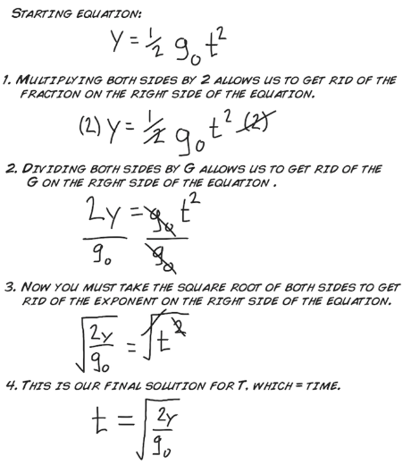
Calculate the reaction time for each of the visual, auditory and tactile drops. How? The good folks at backyardbrains.com have provided the answer for you (right side of the page)

Note that g_{o} = 981 cm/s²

and y = distance dropped (in cm)

Using this, you can find the reaction times and complete the chart below:

Test | Reaction Time: (s)
Visual
Auditory
Tactile

