Mantis Shrimp – The Attack of Elastic Energy

Mantis shrimp – small crustacea that live in warm and shallow water. Some species have “clubs” as part of their limbs that can throw a very powerful punch. Just a few facts about the delivered punch: the acceleration of the punch is similar to a gunshot from a 22-caliber bullet rifle, they can strike the prey with 1500 N of force, the “clubs” move so quickly the water around them boils in the process known as cavitation. Mantis shrimp delivers one of the most powerful punches due to the stored elastic energy in saddle-shaped structure that ensures efficient storage of elastic energy.
In our investigation we will model the mantis shrimp’s saddle-shaped structure by a toy popper. We will make predictions about kinetic and gravitational energy during the popper’s launch and explore possibilities to maximize the transfer of stored elastic energy.

A: Analyzing Popper’s Motion Using Kinematics and Energy
Let’s determine popper’s kinetic energy at the moment of the launch and its maximum height. We will launch the popper of mass 3.9 g from the desk (or floor).
- Represent and Reason. Complete part A of the solution process. What events are important in this situation?
Pictorial Representation
Sketch showing events, coordinate system, label givens and unknowns, describe events

Event 1:

Event 2:

- Calculate and Predict. Use the time of flight to predict the maximum height that toy popper reaches at moment 2 and launching velocity at moment 1. You will need to make a measurement using the Acoustic Stopwatch feature of the Phyphox App to make those predictions. Place the popper on the desk, start Acoustic Stopwatch and record the time of flight.

- Calculate and Predict. Calculate the amount of kinetic energy at the moment of launching (event 1)

- Reason. Describe the energy transfer between moments 1 and 2 and complete the energy bar graph. What assumptions have we made about the energy transfer?
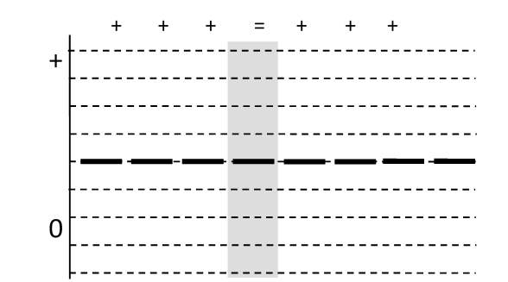
B. Analyzing Popper’s Motion Using Impulse and Energy
Let’s determine popper’s launching speed using the idea of impulse and predict its kinetic energy at the moment of launching. We will launch the popper from the pad of the force sensor and gather the necessary data.
- Represent and Reason. Complete part A of the solution process. What events are important for calculating launching speed using impulse?
Pictorial Representation
Sketch showing events, coordinate system, label givens and unknowns, describe events

Event 0:
Event 1:

- Reason and Represent. Are there any important interactions between the popper and the external environment between events 0 and 1? Complete the physics representation for the system of popper.

Physics Representation
Motion diagram, force diagram, impulse momentum bar chart

- Reason. Based on our observation and considering the small mass of the popper, what reasonable assumption can we make about the force of gravity and the impulse from the gravity during the launch? Based on the assumption, write the impulse -momentum equation.

- Sketch. We can get normal force vs. time graph using force sensor. Place the loaded popper on the force pad and wait for the popper to launch. Sketch the normal force-time graph taken with the force sensor and shade the area for the time between events 0 and 1.
- Measure. Impulse is the area under force-time graph. Determine the impulse from the ground (normal force) by selecting the same area on the SPARKvue, clicking ”Σ” and choosing “Area”. Record the value for the impulse.

- Calculate and Predict. Using impulse-momentum equation predict the launching speed of the toy popper. How does the value of this speed compare to the speed from part A?

- Calculate and Predict. Use the value of launching peed to predict the amount of kinetic energy at moment 1.

- Calculate and Predict. Based on the previous results, predict the maximum height of the popper.

- Reason. Isaac says: “I don’t understand why is the maximum height in part A different from value in part B. Clearly, popper doesn’t go as high as predicted in part B! Something is very wrong here!”. Explain to Isaac what could be the reason for this discrepancy. What other types of energy are involved in this situation?

C. Going higher (or lower)?
- Reason. Imagine that you hold the pencil vertically with one end on the desk. What would happen if you launch the popper from the top of the pencil (don’t do this yet)? How would this launch compare to your earlier launch? Use energy to explain your reasons.

- Reason. Emmy: “I think that popper will go higher because there will be smaller losses due to popping sound and thermal energy from the interaction with the desk.” Marie: “I think that popper will reach smaller height because it has smaller surface to bounce off of.” Albert says: “I think that force “popping” is activated longer, since the bottom of the popper is in contact with the pencil the entire time, instead of a split second. More time, means more time to accelerate, means greater velocity and greater height.” With whom do you agree? Explain.

- Predict and Test. Launch the popper from the top of the pencil. How does this launch compare with your earlier launch?

- Interpret and Reason. How can you explain the observations from two different launches (from the desk and from the pencil) from an energy perspective? What determines the stored elastic energy of the popper? Can stored elastic energy be changed? Can you think of another way to maximize the transfer of elastic energy into gravitational?

Summary: Mantis shrimp evolved to maximize stored elastic energy, but also to maximize the transfer of elastic into kinetic energy and to amplify the power output.

