Science is all about testing models – models of how things work that we cannot see. We set up experiments that ‘tweak’ certain variables, then allow us to observe others. We use the model to predict the outcomes of our tweaks, then observe the results. If the model’s prediction was incorrect, it is discarded or modified in favour of something else. If its prediction is correct, it is retained and used to make further predictions for further experiments.
In electricity, careful observation has allowed us to determine laws that govern the movement of electrons through conductors and resistors. Today, you will use these laws in a POER (predict-observe-explain-reflect), then reflect on the results and the effectiveness of your use of the laws.
In a Predict-Observe-Explain-Reflect, you get the chance to test a scientific model. Today, you will be shown a circuit and asked to predict the outcomes when changes are made to its arrangement. You will then observe what happens during those changes, and be required to explain the observations in terms of your predictions, the theory, and what you have learned.
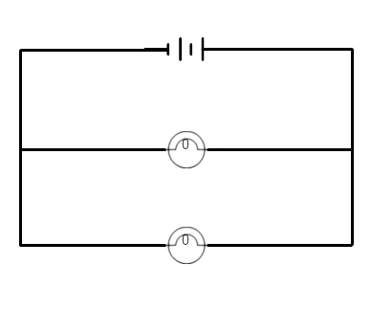
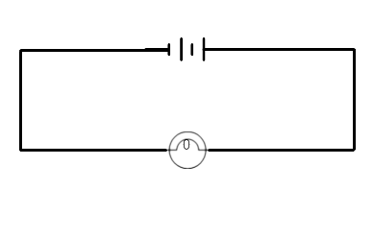
There are diagrams of the various circuits below, and Ohm’s and Kirchoff’s laws are provided for your reference. Good luck!

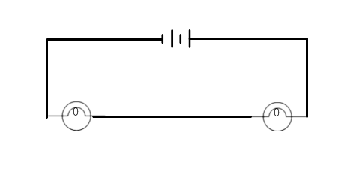

Ohm’s Law: V=IR

Resistors connected in series | Resistors connected in parallel
I_{T} = I₁ = I₂ = I₃ = … | V_{T} = V₁ = V₂ = V₃ = …
V_{T} = V₁ + V₂ + V₃ + … | I_{T} = I₁ + I₂ + I₃ + …
R_{T} = R₁ + R₂ + R₃ + … | 1/R_{T} = 1/R₁ + 1/R₂ + 1/R₃ + …

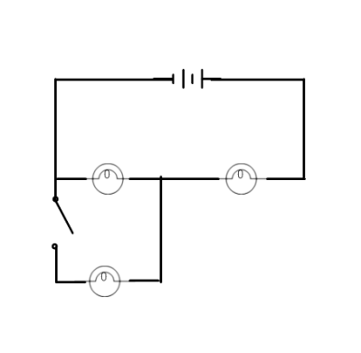
Phenomenon (What are you observing?)
The circuit is hooked up as shown. What happens to the three lights as the final switch is closed (brighter, dimmer, stays the same)?
Predict (What do you think will happen, and why?)
Observe (What do you observe – what actually happens?)
Explain (Why did it happen?)
Reflection (What have you learned? What are your thoughts? What do you understand now? Write something about how this impacted you.)

Teacher Notes
When I run this POE (POER?), I do it after the students have used Kirchoff’s and Ohm’s laws and practiced solving mixed circuits. However, I imagine it can easily be used earlier, provided it’s scaffolded. Here’s the way I’ve done it in the past:
1. I set up a circuit that allows me to switch easily through the different configurations. Usually this involves a fair number of wires, a disconnected section, and several switches.
2. I start with a verbal (discuss with your neighbours) POE about whether increased voltage across a single bulb increases its brightness. I usually couple this with warnings about pushing the voltage too high and what the signs of imminent blowout are.
3. Next, I insert another bulb in series with the first. Sometimes I can set up a ‘short-circuit’ where all I have to do to switch between one single bulb and two in series is to open a switch. POE: are the two bulbs brighter, dimmer, or the same as the one bulb?
4. Next I use a different switch to add a second bulb in parallel with the first bulb (the second series bulb is removed from the active circuit). POE: brighter, same, or dimmer? Note: the question applies to all of the bulbs!
5. Then I set up the circuit that allows me to do the final circuit, with two bulbs in series and a third in parallel with one of them, connected by a switch. I turn the power on with the switch open to mimic the situation in #3. Then I ask them what happens to the three bulbs (brighter, same, dimmer) when I close the switch. This is the POE: they are required to write their answer and explanation down, and I make sure everyone has written something down before I show them.
6. I flip the switch. No one in grade 9 has gotten it right; a handful in regular grade 11 physics got it right; about half my IB class got it right. The two bulbs in parallel are now dimmer than the one was at first, and the bulb that completes the series gets brighter. This is because two bulbs in parallel decrease the resistance in that part of the circuit, which decreases the overall resistance of the whole circuit. Decreasing the resistance increases the current overall, which means the bulb in series receives more current. The parallel combination also receives more current, but that current is split between the two bulbs so the result is less current through each of the bulbs than in the original bulb before the switch was closed. Encourage the students to put numbers on the resistors and work it out for themselves! At the end, they write a little reflection about the activity which you can collect for your own feedback. I usually just use it as a discussion point.

Materials: I like to use Christmas lights, because you can buy 400 of them for about $40 on a reel, so you don’t mind if they get blown out. Also, string lights give your students a chance to cut and strip wire and work out connections – a pair of wire strippers is only about $10! Beyond the lights, you need switches, DC power sources, and wires (ideally alligator clip).

Encourage the students to build some POEs of their own; I usually put a modified version of this circuit in a question on the test or quiz.
HAVE FUN!
The QR code below is a link to this document. Here is the link:
https://drive.google.com/open?id=1O9U56uLgmR3yXo6sIgOWp0Gg060R7WRk

My email:
patersona@hdsb.ca

Below are some photographs of the general way I set the circuit(s) up:

