SPH4U Gravity Assist Motion

In September 2017 the Cassini mission ended after 20 years in space. The grand finale was comprised of 22 orbits through the gap between Saturn and its rings, slowing down, ever closer to Saturn and finally burning up in the atmosphere. Cassini was able to get to Saturn and to preform grand finale, using the gravity assist maneuver, often referred to as the “slingshot maneuver”. The technique uses gravity of another body to change speed or orbital path of a spacecraft. Cassini left Earth with a speed of 4 km/s but needed a speed of 10 km/s to reach Saturn.
So, how did Cassini end up at Saturn? Where did the extra speed come from? Let’s find out!
A: 1D Collision___________________________________________________________________________
Your teacher has a track with two carts set up. A small cart A (250g) is moving left and a large cart, cart B (1.0kg) is moving to the right. The speed of the large cart is greater than the speed of the small cart. They collide magnetically and travel on a frictionless track.
- Predict and Test. Describe how fast and in what direction each cart will move after the collision. Draw a sketch of the “after” moment. Test your prediction.
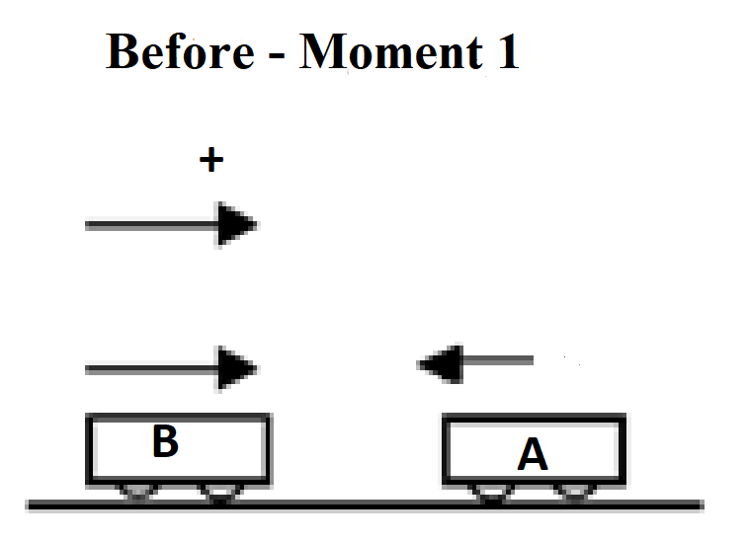

- Reason. Which object has gained energy? Which has lost energy? Is energy lost to the environment? What type of collision is this? Explain.

- Represent. Draw an energy flow diagram for the system of the two carts. Complete a momentum bar chart and an energy bar chart for the system of the two carts.
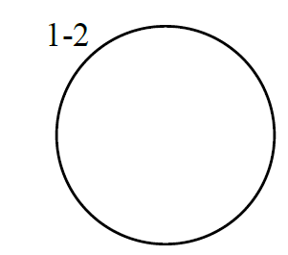 | 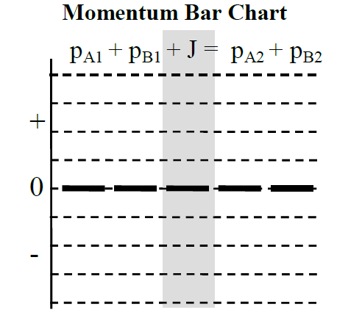 | 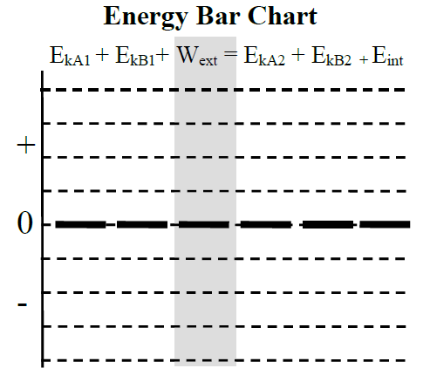

- Represent and Solve. Write an momentum equation and an energy equation for the system of two carts.

- Represent and Solve. Rewrite these equations so that all the terms with mass A are on the left side and all the terms with mass B are on the right side of the equal sign.

- Represent and Solve. Divide the energy equation by the momentum equation to get a relationship between the initial and final velocities of both carts.

- Represent and Solve. We are interested in the velocity of the smaller mass (cart A) after the collision. Write the expression for velocity A after collision.

- Calculate. If the magnitudes of velocities v_{B1} and v_{A1} are 5.0 m/s, 4.0 m/s respectively, and a motion sensor measures velocity of v_{B2} to be 1.4 m/s, calculate what value would the motion sensor measure for velocity v_{A2}? Remember that velocity is vector quantity.

- Explain. How does the speed of smaller cart, cart A, compare before and after the collision?

**Check this with your teacher. **

B. Gravity Assist Motion__________________________________________________________________
It is time to go back to our original question. How did Cassini gain the extra speed necessary to reach Saturn?
- Predict and Represent. The figure bellow shows the idealized arrangement, with a spacecraft of mass A moving at speed v_{A1} towards the planet of mass B, moving at speed of v_{B1.} The spacecraft does a U-turn around the back side of the planet and emerges at speed v_{A2.} Draw a sketch of “after” moment.
Before – Moment 1 | After – Moment 2
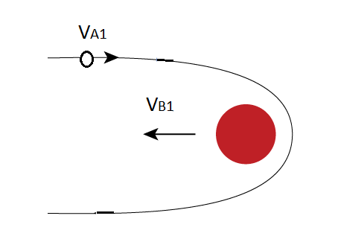

- Reason. Marie says: “I think that we can use a 1-D elastic collision model to explain interaction between a spacecraft and a planet. The spacecraft and planet interact only through gravitational interaction, which is internal for the spacecraft-planet system.” Emmy says: “Hmm, wouldn’t that mean that the planet too would have to change speed after the interaction? So, if we want the spacecraft to speed up that would mean that the planet has to slow down after the spacecraft flies by. That does not make any sense. I don’t think this is an elastic collision.” Who do you agree with? Explain.

- Represent. We can use the elastic collision analysis explained in part A to understand how spacecrafts change speed as they pass close to a planet. The small mass A will act as a spacecraft and the larger mass B will act as a planet. Write the impulse-momentum equation for the spacecraft-planet system. Refer to the question A#4.

- Represent. Rewrite the impulse-momentum expression to solve for the difference of planet’s velocities after and before the interaction (v_{B2} – v_{B1}).

- Calculate and Reason. The mass of the spacecraft is of order 10³kg and the planet is of order 10²⁷kg. Calculate the ratio of spacecraft mass and planet mass (m_{A}/m_{B}). What approximation can we make about that ratio?

- Interpret. What reasonable assumption can we make about initial and final velocities of the planet?

- Represent and Solve. Using the approximation that initial and final speed of the planet are the same, and answer to question A#7, write the expression for the spacecraft speed after interaction with planet.

- Reason and Explain. Would the spacecraft gain speed if the planet was not moving? Would the spacecraft gain speed if it doesn’t make complete U-turn around the planet, but instead completes different flyby trajectory? Explain.

- Predict. Your teacher has as setup that models the gravity assist motion. It consists of a rotating magnet that acts as a planet, and a small marble that passes by it. Make a prediction about what you will observe. Go to the front and make observations.

Summary. Explain how the gravity assist maneuver works. Include references to total energy, planet velocity and spacecraft velocity.

Cassini, on its way to Saturn acquired extra speed from four planetary encounters – with Venus, Venus again, Earth, and Jupiter.

