Ontario Association of Physics Teachers
Electrical and Computer Engineering
University of Toronto
Conference 2014

Physics: The Roots of STEM Education
Science Technology Engineering Mathematics
May 8 – 10, 2014
Welcome! Please check your registration for confirmation of the sessions you have registered for. The location of each session is indicated in the program.

Thursday May 8, 2014

Registration and Dinner
6:00 pm – 7:30 pm

Welcome
BA 1170
7:30 pm – 7:40 pm

Activities/Tours
BA 1170
ECE Tours
Demo Derby

Social
O’Grady’s
9:00 pm – 11:00 pm

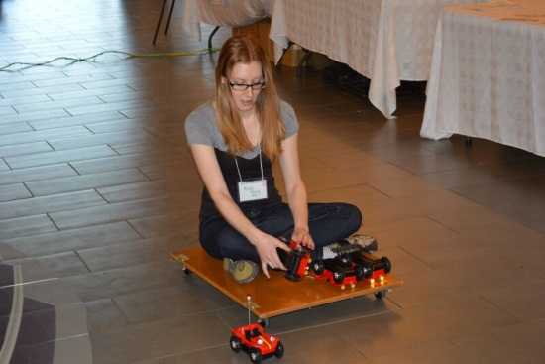
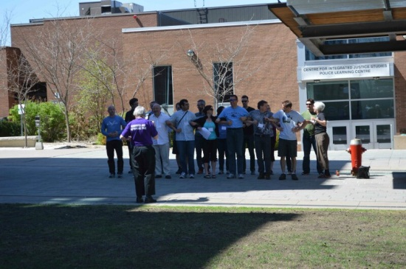
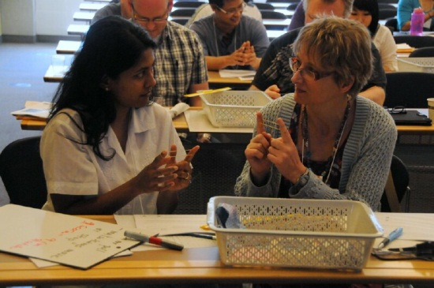

Friday May 9, 2014

Welcome
8:45 am – 8:55 am

Keynote - Bonnie Schmidt – Let’s Talk Science
BA 1160
8:55 am – 9:45 am

Break
9:45 am – 10:15 am

Two single sessions (A & B) or One Double Session (AB)
10:15 am – 12:00 pm

Lunch
Noon – 1:30 pm
Boxed lunches are provided in Atrium

Session C
1:30 pm – 2:45 pm

Break
2:45 pm – 3:15 pm

Session D
3:15 pm – 4:30 pm

Closing Remarks for the Day
The Great Giveaway
4:30 pm – 5:00 pm
BA 1160

Dinner
You may sign up to one of five restaurants at the Registration Desk

Evening meeting [lace will be announced for additional social time after dinner!

Saturday May 10, 2014

Session E
9:00 am – 10:15 am

Break
10:15 am – 10:45 am

Session F
10:45 am – 12:30 pm

Ontario Association of Physics Teachers
Electrical and Computer Engineering
University of Toronto
Conference 2014

Physics: The Roots of STEM Education
Science Technology Engineering Mathematics
May 8 – 10, 2014

Friday May 9, 2014

Friday May 9, 2014 Workshops (Session A & B or Session AB)
Session A  10:15 am - 11:00 am | Session B  11:15 am - 12:00 pm | Double Session AB  10:15 am - 12:00 pm
01 Negative-Refraction, Super-Resolution Imaging and Invisibility with Metamaterials  George V. Eleftheriades  Electrical and Computer Engineering  University of Toronto  Room BA 2185 | 05 Engineering Education – Emerging Trends and Innovations  Susan McCahan  University of Toronto  The Inverted (Flipped) Classroom Lessons Learned from a Second-Year Physics Course  Micah Stickel  University of Toronto  Room BA 2185 | 09 STEM, STSE and Relevance  Mars Bloch  Room BA 2165
02 Perimeter Institute: What Good is a STEM Education?  Damian Pope  Room BA 2145 | 06 Outreach Opportunities  Sara Cormier, Patrick Whippey, DEEP/Engineering  Room BA 2145
03 Girls in Science  Shohini Ghose  Centre for Women in Science at WLU  Dawn Britton  University of Toronto Engineering Outreach  Chandra Boon  Mindset  Room BA 2159 | 07 Universal Tool for Tinkering  Hasan Shodiev  Sir Wilfrid Laurier University  Room BA 2159 | 10 Engineering Contests and STEM  Roberta Tevlin  Andrew Moffat  Room BA 2175
04 The ability of our students to think scientifically: probably not as great as we think  Dr. David Harrison  University of Toronto  Department of Physics  Room BA 2155 | 08 Applying Physics Principles to Build a Career Roadmap  Carolyn Burgess  Ian Burgess  Room BA 2155

Friday May 9, 2014 Workshop Session C
1:30 pm – 2:45 pm
Number | Title | Presenter(s) | Location
11 | Sustainable Energy Systems  University of Toronto | Nazir Kherani  Advanced Photovoltaics and Devices Research Group  Olivier Trescases  High-Efficiency Power Management  Zeb Tate  Smart Grid Design  Micah Stickel | BA 2185
13 | New Pedagogies for Teaching Physics | John Caranci | BA 2145
14 | From Black Currant to Green Current: A New Old Way to Catch Sunrays | Franco Gaspari  UOIT | BA 2155
15 | STEM Problem Solving | Chris Meyer | BA 2165
16 | Studying the Climate - Resources for High School | Aubyn O'Grady  CANDAC - University of Toronto  Shawn Brooks | BA 2175

Friday May 9, 2014 Workshop Session D
3:15 pm – 4:30 pm
Number | Title | Presenter(s) | Location
17 | Biomedical Engineering  University of Toronto | Stewart Aitchison  Biomedical Sensing and the ChipCare Project  Willy Wong  Neural, Sensory Systems and Rehabilitation  Dr. Micah Stickel | BA 2185
18 | Resources and Supports for Physics Teachers | Stacey Joyce  Perry Kotkas  Dr. Sacha Noukhovitch | BA 2145
19 | Getting the 21st century H.O.T.S.* (*higher-order-thinking-skills) | Dave Doucette  Edward Gissing | BA 2155
20 | Fun with Waves and Sound  University of Toronto | Jason Harlow  Andrew Myertholen | Physics  MP125-A
21 | Perimeter Institute: The New Cosmology Resource | Damian Pope  Kevin Donkers | BA 2165
22 | Bridging the Transition to 1st Year Physics with PER | James Fraser  Queen’s University  Martin Williams  University of Guelph  Aaron Slepkov  Trent University  Tetyana Antimirova  Ryerson University | BA 2175

Saturday May 10, 2014

Saturday May 10, 2014 Workshop Session E
9:00 am – 10:15 am
Number | Title | Presenter(s) | Location
23 | Engineering Design and Leadership in the High School Science Experience  University of Toronto | Patricia Sheridan  Jason Foster | BA 2185
24 | Physics of Music | Rolly Meisel | BA 2145
25 | Teaching Physics by Coding | Richard Taylor | BA 2155
26 | S.T.E.M. In Model Schools for Inner Cities | Donna Quan – TDSB Director of Education  Vicky Branco – TDSB Superintendent of Education  Simona Emiliani | BA 2165

Saturday May 10, 2014 Workshop Session F
10:45 am – 12:30 pm
Number | Title | Presenter(s) | Location
27 | "Particles Smarticles": Using Group Interactive Demonstrations to Model Particle Behavior | James Ball  Saara Naudts | BA 2145
28 | Represent! Multiple Representations as the Key to Deep Understanding | Chris Myer  Tim Langford | BA 2155
29 | Redefining Science in a School | Lisa Lim-Cole  Margaret Scora | BA 2165

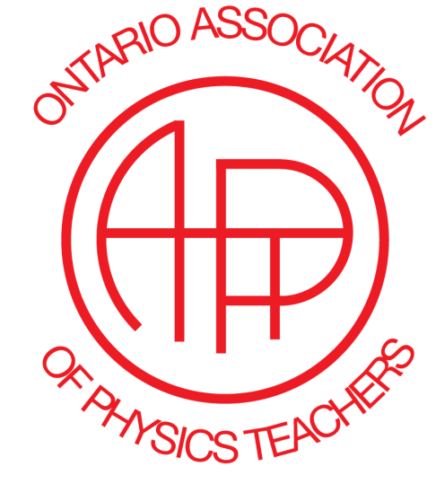
GET INVOLVED IN OAPT!
Join a Committee! We have many tasks “BIG” and “small”. Every contribution matters!

Write an Article for the OAPT Newsletter!

Contact Lisa Lim-Cole at: Lisa_Cole@durham.edu.on.ca

