Automotive Design

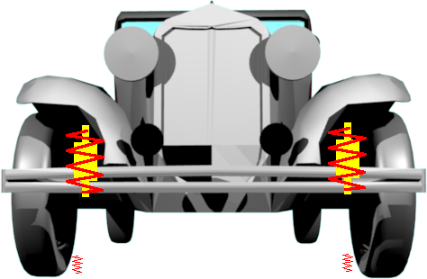

Objective: To experimentally determine the relationships between spring stiffness (spring constant) and period of oscillation of a spring/mass system.

Experiment 1: SPRING CONSTANT

To determine the relationship between force and extension of a spring

Method: Use force to extend a spring, take at least five measurements, plot graph, and determine relationship and constant of proportionality.
Please note that although the force or the extension can be the independent variable that for purposes that will become clear you are asked to plot Force on the y-axis.

Experiment 2: Simple harmonic motion

Use the same spring as above and determine the relationship between mass and period of a mass/spring system.

This is a formal lab and will be due on _____________________

1. Now design a spring system for a car of mass 1000kg that has on average 4 occupants of each 785kg each. In order to have a smooth ride the car should rise and fall with a period of 3 seconds after it goes over a bump. What sh0ould be the spring constant of the springs at each wheel in order to produce a spring mass system of this period?

2. As it would be unpleasant to bounce up and down in a car indefinitely every time we drove over a bump in the road, cars are equipped with shock absorbers. Use the internet or other resources to research damping on cars and explain how this would make for a smoother ride.

