The Next Generation Space Telescope at L2

The Hubble Space Telescope (HST) has been in operation for many years. The Next Generation Space Telescope (NGST – also known as the James Webb Space Telescope) is due to be launched around 2015 and will have some added features over The Hubble. This is a part-research and part-problem solving assignment. You are to work independently to prepare a research report, which describes in your own words the following:

Introduction to space telescopes
Summary of the history of the Hubble
The advantages and abilities of the Hubble in comparison to terrestrial telescopes
Calculations showing the derivation of the orbital speed and height of orbit of the Hubble. Calculate its orbit and comment on the effect of communication with Earth
Details of the NGST and its advantages over the Hubble including reasoning for its positioning at L2 and why in words L2 is the optimum position for it.
Elementary calculations on the distance of L2 from Earth are required. Use a FBD and take into consideration the gravitational forces of the Earth and Sun only on an object at L2. Note: you do not need to complete the calculations as the mathematics is beyond the scope of this course. It is expected that you will be able to derive a formula of terms with only the distance of L2 to Earth as the unknown. You can then research the L2 distance and put it into you equation. Comment on the accuracy.
Hints.
Use more than one source from each of Internet and book/magazine reference materials. Use you own words to concisely convey information.
The period of an object at L2 is the special feature and how the gravitational forces will allow an object to remain there against, what may seem at first glance, impossible odds.
Google search NGST L2
Show references

PTO

You will be required to produce:

1. A report with all of the above included in it.

2. A presentation to class on

- Why L2 is ideal for this telescope and why the James Webb telescope benefits from being at this distance from Earth. OR
- Describe the SOHO telescope and all about the L point is occupies OR
- The development of the 5 L (LaGrange) points and which points are suitable for other space telescopes (SOHO) .OR
- The Hubble telescope, its position in space and orbit and how it differs from the James Webb telescope. OR
- Something else related to this project.

These presentations are a minimum of 2 and maximum of five minutes so research thoroughly and aim to impress your fellow students (and me)

You MUST see Mr. Atherton before you choose a presentation as only one will be given to each student (first come first serve)

For Teachers only:
This is really a research project, the math to determine L2 is beyond introductory university math but the check can be done with the Free Body Diagram and the mass of the Earth and distances from the website below
http://www.jwst.nasa.gov/orbit.html
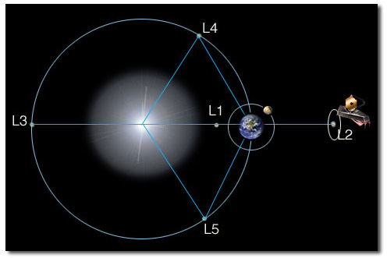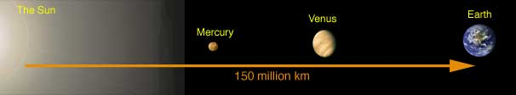

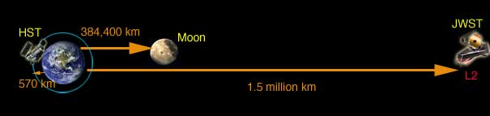
Me =

