Two Sides of the Same Coin:
Fun with Motors and Generators

Facilitator:
Micah Stickel, Lecturer,
Edward S. Rogers, Sr., Department of Electrical and Computer Engineering, University of Toronto
m.stickel@utoronto.ca
(416) 978-7805

Workshop Objectives
By the end of this workshop you should,
- Understand how current-carrying wires placed in a magnetic field experience a force
- Have a greater understanding of the motor principle
- Have had an experience building a simple DC motor and testing it out
- Understand the basic laws behind how an electrical generator works, and how this relates to the operation of a motor
- Understand some of the practical challenges in the design of effective generators
- Have gained a stronger appreciation for the work of an electrical engineer
This workshop will provide you with a template for a possible set of exercises related to motors and generators. Specifically, this workshop will address the following expectations from the 2008 Ontario Curriculum Grade 11 Physics SPH3U (pages 192 – 193):
F2.7 | investigate electromagnetic induction, and, using Lenz’s law, the law of conservation of energy, and the right-hand rule, explain and illustrate the direction of the electric current induced by a changing magnetic field
F2.8 | construct a prototype of a device that uses the principles of electromagnetism (e.g., an electric bell, loudspeaker, ammeter, electric motor, electric generator), and test and refine their device
F3.4 | explain Ohm’s law, Kirchhoff’s laws, Oersted’s principle, the motor principle, Faraday’s law, and Lenz’s law in relation to electricity and magnetism
F3.5 | describe the production and interaction of magnetic fields, using diagrams and the principles of electromagnetism (e.g., Oersted’s principle, the motor principle, Faraday’s law, Lenz’s law)
F3.6 | explain the operation of an electric motor and a generator, including the roles of their respective components

Department Background
The Edward S. Rogers, Sr., Department of Electrical and Computer Engineering at the University of Toronto is one of the premier ECE departments in the world. Our department consists of over 70 faculty members who create both world-class research as well as unique and engaging learning experiences at the undergraduate and graduate levels. Currently we have around 1200 undergraduate students throughout our four-year program and these are essentially equally divided between electrical and computer engineering students. At the undergraduate level we strive to provide a rigorous theoretical foundation coupled with the best hands-on experiences possible through our extensive laboratory facilities.

Exercise #1 – The Motor Principle
The fundamental purpose of a motor is to:
Convert electrical energy into mechanical energy.
or
Motor
Input:
Electrical Current
Output:
Mechanical Motion

To begin our investigation of motors and generators we can consider this important fact:
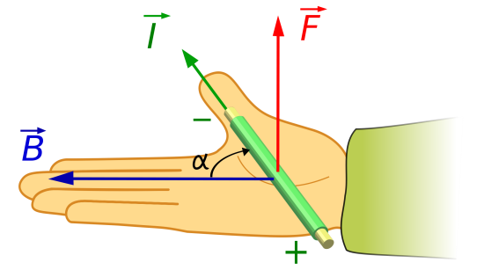
If a current-carrying wire is placed in a magnetic field, the wire will experience a force according to the right-hand-rule, as shown to the right.

This can also be expressed in equation form as:

$$Force is proportional to\left[\begin{aligned}Strength of the \\ Magnetic Field, B\end{aligned}\right]×\left[\begin{aligned}Strength of the \\ Current, I\end{aligned}\right]×\sin\left[\begin{aligned}Angle between \\ B and I, α\end{aligned}\right]$$

$$F∝BI\sin{α}$$

If the magnetic field is at a right angle to the flow of the current (as shown in the figure above), then $α=90°$, and $\sin{α}=\sin{90°}=1$. Thus, the equation simplifies to:
$$F∝BI$$

Question 1.1: The Motor Principle
Given this important fact, consider the three situations below. In all three cases the magnetic field is upwards. In the first case the current in the wire is from left to right, while in the second case the current in the wire is from right to left, and in the third case there is no current flowing in the wire.

For each case, on your own describe and draw the direction of the force, $F$, that the wire would experience.
No
Current
Magnetic Field, $B$
Wire
Case #3

Case #1

Magnetic Field, $B$
Current, $I$
Wire
Wire
Case #2

Current, $I$
Magnetic Field, $B$

Question 1.2: The DC Motor
Now consider a square metal loop which is placed in the presence of a magnetic field. The loop is connected to a battery, which results in a current in the loop which flows from the positive terminal of the battery to the negative terminal. Again the magnetic field is upwards, and the loop is fixed so that it can rotate about an axis, as shown.

As a group, predict how the loop will rotate for the two cases shown below. Observe that since the loop has a fixed axis of rotation, the only forces that matter are the ones on the top and bottom pieces of the loop.

In the first case the loop is oriented so that the battery is at the bottom. In the second case, the loop has been rotated a half-turn, so that the battery is now at the top.
Case #2:
Battery at the Top

Magnetic Field, $B$
Current, $I$
Axis of rotation
$+$ Battery $-$
Case #1:
Battery at the Bottom

Magnetic Field, $B$
Current, $I$
Axis of rotation
$+$ Battery $-$

Question 1.3: Practical DC Motor Design
Given what you have found in Question 1.2, discuss as a group why this setup would result in a useful motor.

Put on your engineering hats, and come up with two things that you could change as the loop moves from Case #1 to Case #2 in order to make this a better motor.

Exercise #2 – Building Your Motor

We can now take the motor principle and use it to build a simple DC (direct current) motor. Another very important fact is:

If a current-carrying loop has many turns, then the force that it experiences in the presence of a magnetic field will be multiplied by the number of turns. This means that if a loop has N turns, then the force is now:
$F∝NBI$.

Therefore, to increase the speed of a motor we can use a loop which has many turns. This is what you will do for your motor design.

Once you are finished, your motor should look something like the picture shown at the bottom of page 7.

In your kit and on your table you have 10 parts as shown in the picture below:
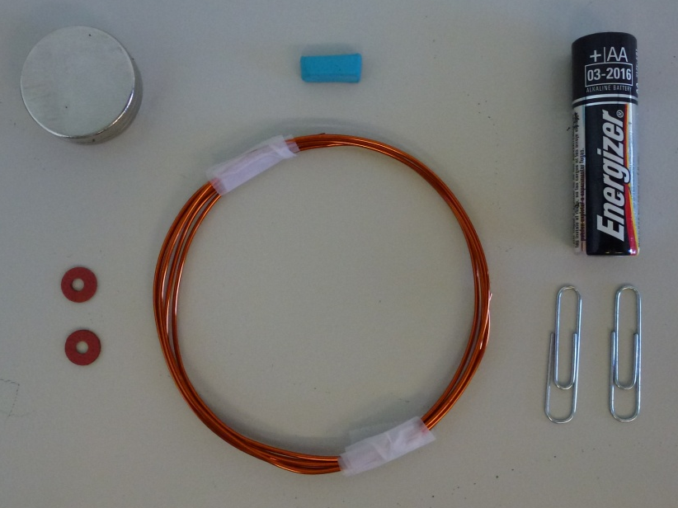
Three 1” rare-earth magnets
(Lee Valley, part #99K32.13)
1.1 m length of insulated wire
(18 AWG Magnet Wire)
A 1.5 V battery
Two paper clips
Two insulating washers
(Any plastic or insulating washers will suffice, and these can usually be found at any home-improvement store)
One piece of blue tack
Tape
Scissors
1.5” plastic canisters
Pliers

IMPORTANT: The three magnets you have are VERY strong. You need to handle them carefully as they can snap together with tremendous force (and cause bad blisters if your finger gets caught!). Also, make sure to keep them away from other magnets, and any credit cards, debit cards, and computer equipment.

The steps to building your motor are described in the following pages.
Creating Your Loop (Rotor)
- Cut two pieces of tape about 1” long, and place them at the edge of the table. These will be used to tape your loop together.
- Create your loop with a number of turns by wrapping the wire around the round plastic canister. You should leave about 2” on either side of your loop so start wrapping your loop at the black mark near the end of your wire.

When you are finished wrapping the wire, tape your loop together as shown in the picture below. Make sure that the two straight ends are coming out from the loop at the center of the loop. This will make sure that your loop is well balanced.

- Use the scissors to scratch away the insulating cover of the wire off the entire length of the 2” straight sections on either side of the loop. It is very important that you SCRATCH OFF THE INSULATION ONLY OVER HALF OF THE WIRE, as shown. Scratch off the same side of the wire on both 2” straight sections.

Make sure you do not scratch off too much or too little. When you are finished you should clearly see the silver wire over half of the wire, and the orange insulation over the other half.

Insulation on bottom part of both straight sections left alone
Insulation on top part of both straight sections scratched off
Creating Your Motor Base (Stator)
- Take each of the paper clips and fold them according to the pictures below. These will form the support for your loop.
Do this for both paper clips
Bend the small section downwards

Bend half of the larger end upwards

- Tape these paper clips to the battery.

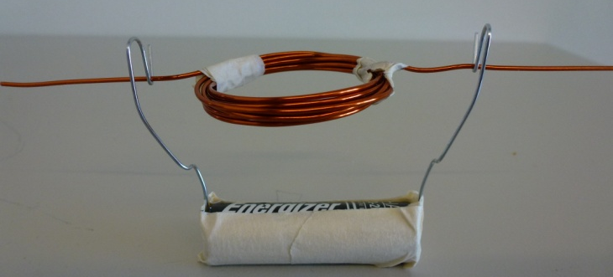
- Bend the paper clips outward so that there is enough room for your loop to fit.

- Place the insulating washers on the straight sections of your loop at a point where they will just hold the loop onto the bent paper clips.
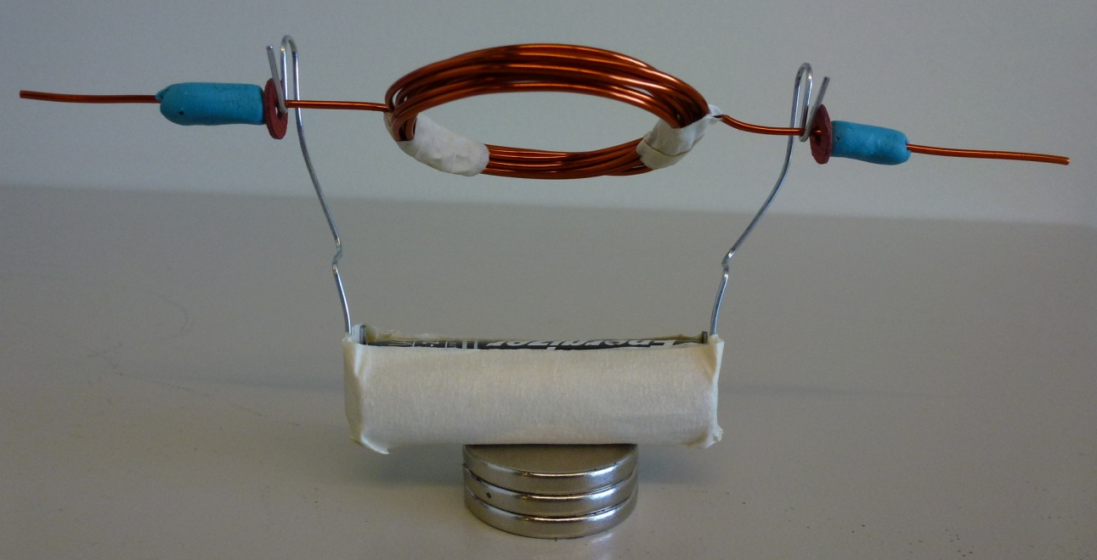
- Place a piece of blue tack on the wire to keep the washers from falling off of the straight sections of the loop.
Testing Your Motor
- Place the motor base on top of the three magnets.
- Place the loop in the paper clip holders so that the washers are on the outside of the paper clips.
- Give the loop a bit of a nudge…
- If your loop does not start rotating, you should make sure that the insulation is totally scratched off from one half of the wire. In this case, use the scissors again to scratch away at the wire to make sure the wire is totally exposed over one half and still insulated over the other half.

You may also need to slightly adjust the paper clip holders so that there is not too much friction between the washers and the holders.

Answer the following questions. Once your have answered them on your own then discuss them as a group.

Question 2.1: Practical Motor Design
Why did you only scratch off the insulation from one half of the wire? Think back to your results of Questions 1.2 and 1.3.

Question 2.2: Speed of the Motor
Suppose you wanted the motor to go faster. What three things could you change to make this happen?

Question 2.3: Magnet Orientation
What would happen if you reversed the orientation of the magnets below the battery? Would it be possible to use this motor to determine which side of the magnet is the north pole and which is the south pole?

Exercise #3 – The Other Side of the Coin: The Generator

Recall that the fundamental purpose of a motor is to:
Convert electrical energy into mechanical energy
or
Motor
Input:
Electrical Current
Output:
Mechanical Motion

While the fundamental purpose of a generator is to:
Convert mechanical energy into electrical energy
or
Generator
Input:
Mechanical Motion
Output:
Electrical Current

So, we can see that motors and generators are essentially the same thing just with different inputs and outputs. Therefore, we should be able to take our motor and “flip the coin” to use it as a generator.
Let us consider the different alternatives for the mechanical input of a generator. Somehow we need to rotate our loop using some mechanical motion. This could be done in a variety of ways:
- Place a paddlewheel in some fast moving water which would cause our loop to rotate. This is the basic idea behind hydroelectric power
(i.e., the Niagara Falls generating station).

- Boil some water to generate a lot of steam which can be used to turn our loop through a “steam turbine”. This is the basic idea behind nuclear power (where the water is heated through the nuclear reactions), and coal-fired and natural gas power plants (where the water is heated through the burning of fossil-fuels fuels like coal and natural gas).

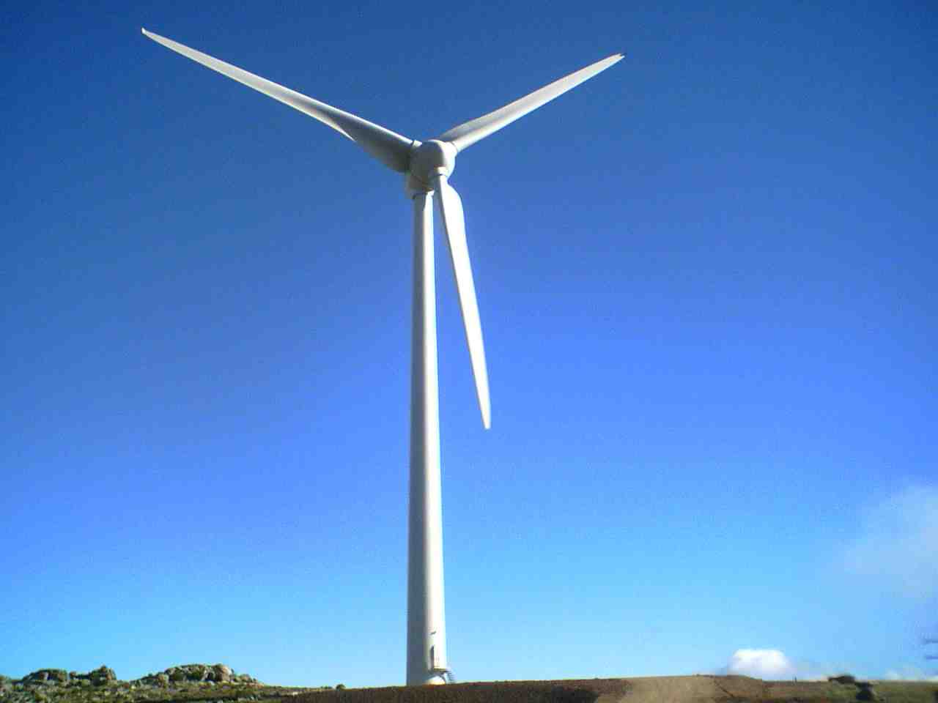
- Create a wind turbine, which harnesses the power of the wind to turn the loop. This is the basic idea behind wind farm electricity generation.

Question 3.1: Generator Output
The fundamental law behind the operation of the electric motor is the motor principle. While, the fundamental law behind the operation of the electric generator is Faraday’s law. Recall, that Faraday’s law can be stated as:
“When a magnetic field through a closed coil changes, an electric current is created in the coil. This is called an induced current.”

It can be shown that the strength of this induced current is proportional to:

$$\left[\begin{aligned}Number of Turns \\ of the Loop, N\end{aligned}\right]×\left[\begin{aligned}Area of \\ the Loop, A\end{aligned}\right]×\left[\begin{aligned}Speed at Which the \\ Magnetic Field Changes, ω\end{aligned}\right]$$

$$I_{induced}∝NAω$$

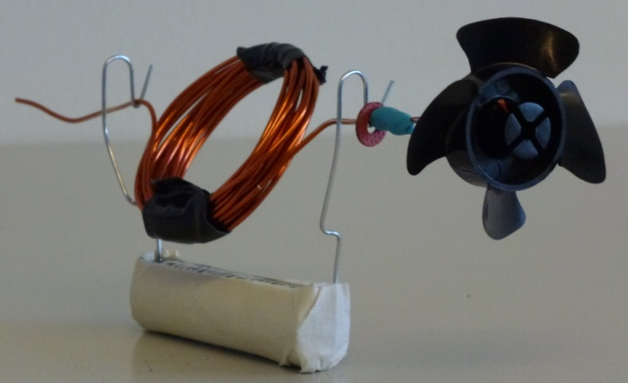
If you took your motor, placed a fan blade on it as shown, and exposed it to a strong wind source your motor would become a generator. However, the strength of the electricity ($I_{induced}$) would be very weak.

As a group, determine three ways in which you could increase the strength of your generator output. Consider each way as an engineer might think about them. Are some more expensive than others? Are there other issues to consider such as weight or friction?

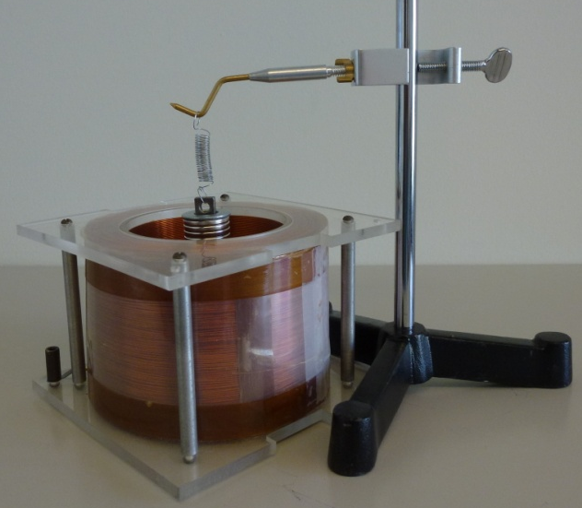
Question 3.2: Generator Demonstration
Another design for an electric generator is to have a magnet oscillate on a spring inside a multi-turn coil, as is shown to the right. This meets all the requirements for electricity generation, namely:
- A closed coil, and
- A changing magnetic field inside the closed coil (through the movement of the magnet inside the coil).

If you use an oscilloscope to measure the current induced in the coil, you would see the picture to the right.
Time
Generated Electrical Signal

As a group, discuss the reasons why the induced current has a sinusoidal characteristic? Recall, that Lenz’s law states

“The magnetic field that is induced, or created, by a magnet moving through a closed coil will always act in opposition to the change of the magnetic field due to the moving magnet.”

