Two Sides of the Same Coin: Fun with Motors and Generators

Answers for Attendee Notes
Exercise #1 – The Motor Principle
Question 1.1: The Motor Principle
Given this important fact, consider the three situations below. In all three cases the magnetic field is upwards. In the first case the current in the wire is from left to right, while in the second case the current in the wire is from right to left, and in the third case there is no current flowing in the wire.

For each case, on your own describe and draw the direction of the force, $F$, that the wire would experience.
No
Current
Magnetic Field, $B$
Wire
Case #3
Since there is no current the wire will not experience a magnetic force.

Case #1
The wire would experience a magnetic force which is out of the page.

Magnetic Field, $B$
Current, $I$
Wire
Wire
Case #2
The wire would experience a magnetic force which is into the page.

Current, $I$
Magnetic Field, $B$

Question 1.2: The DC Motor
Now consider a square metal loop which is placed in the presence of a magnetic field. The loop is connected to a battery, which results in a current in the loop which flows from the positive terminal of the battery to the negative terminal. Again the magnetic field is upwards, and the loop is fixed so that it can rotate about an axis, as shown.
As a group, predict how the loop will rotate for the two cases shown below. Observe that since the loop has a fixed axis of rotation, the only forces that matter are the ones on the top and bottom pieces of the loop. In the first case the loop is oriented so that the battery is at the bottom. In the second case, the loop has been rotated a half-turn, so that the battery is now at the top.
Case #1:
Battery at the Bottom
The top wire will have a magnetic force out of the page, and the bottom wire (with the battery) will have force into the page.
Magnetic Field, $B$
Current, $I$
Axis of rotation
$+$ Battery $-$
Case #2:
Battery at the Top
The top wire will have a magnetic force into the page, and the bottom wire (with the battery) will have force out of the page.

Magnetic Field, $B$
Current, $I$
Axis of rotation
$+$ Battery $-$

Exercise #1 – The Motor Principle (continued)
Question 1.3: Practical DC Motor Design
Given what you have found in Question 1.2, discuss as a group why this setup would not result in a useful motor.
From a consideration of the forces in Cases #1 and #2 of Question 1.2, it is possible to see that the direction of the rotation of the loop changes every half-turn. This means that this loop would simply oscillate back and forth between the situations depicted in Cases #1 and #2 rather than make a full rotation. For a motor to be useful in most practical applications it would need to make many full rotations every second, rather than oscillate back and forth.

Put on your engineering hats, and come up with two things that you could change as the loop moves from Case #1 to Case #2 in order to make this a better motor.
From the motor principle, the magnetic force is caused by two main quantities: (a) a current in a wire, $I$, and (b) the magnetic field applied to the wire, $B$.

Therefore, if we change the direction of one of these quantities every time the loop makes a half-turn (i.e., rotates by 180°), then the direction of rotation will not switch and the loop can continue on to make a full rotation.

So, the two things we can change to make this a better motor is:
- The direction of the current in the loop, and
- The orientation of the magnetic field.

The most common way this is done in practice for DC motors is to change the direction of the current by changing how the loop is connected to the battery every half-turn. This is the purpose of a commutator (http://en.wikipedia.org/wiki/Brushed_DC_electric_motor ).

There are other designs such as the brushless DC motor design (http://en.wikipedia.org/wiki/Brushless_DC_electric_motor), in which the switching of the current (commutation) is done electronically rather than mechanically through brushes.

There are a number of very nice online resources (java applets) which illustrate this nicely:
- http://www.magnet.fsu.edu/education/tutorials/java/dcmotor/index.html
- http://library.thinkquest.org/27948/motor.html
- http://www.phy.ntnu.edu.tw/ntnujava/index.php?topic=912.0

Another very interesting DC motor design is the Mendochino motor, which relies on solar power rather than a battery (see http://www.chessplayingrobot.com/id4.html, and on YouTube, http://www.youtube.com/watch?v=Ncx2eVpWUzw)
Exercise #2 – Building Your Motor

Question 2.1: Practical Motor Design
Why did you only scratch off the insulation from one half of the wire? Think back to your results of Questions 1.2 and 1.3.
This is a simple way to implement the commutation required in order for the loop of a DC motor to make a full rotation. Instead of switching the direction of the current, we simply turn off the current for one half of the rotation. This means that there is never an opposing force causing the rotation to switch directions. In this case, the inertia of the loop’s rotation carries it through the half-cycle in which there is no current through the loop, and thus no magnetic force.

Question 2.2: Speed of the Motor
Suppose you wanted the motor to go faster. What three things could you change to make this happen?
The speed of the motor is directly related to the strength of the magnetic force which the loop experiences. Therefore to increase the speed we need to increase the strength of this force, which means we can:
- Increase the number of turns in the loop,
- Increase the current in the loop (i.e., use a stronger battery), and/or
- Increase the strength of the magnetic field (i.e., use a stronger magnet).

Question 2.3: Magnet Orientation
What would happen if you reversed the orientation of the magnets below the battery? Would it be possible to use this motor to determine which side of the magnet is the north pole and which is the south pole?
Since the direction of the magnetic force depends on the direction of the magnetic field (through the right-hand-rule), if we switch the orientation of the magnet then the rotation of the motor’s loop will also switch.

This means that we can determine the direction of the magnetic field (and thus the orientation of the poles of the magnet) by considering the direction of the loop’s rotation and the direction in which the current flows through the loop.
Exercise #3 – The Other Side of the Coin: The Generator

Question 3.1: Generator Output
As a group, determine three ways in which you could increase the strength of your generator output. Consider each way as an engineer might think about them. Are some more expensive than others? Are there other issues to consider such as weight or friction?
The three main quantities that will control the strength of the electrical output of this generator are:
- The number of turns in the loop,
- The area of the loop, and
- The rate of change of the magnetic field within the loop.

So, to increase the strength of the output we could increase each of the (or all of these) quantities. However, from an engineering perspective each has its advantages and disadvantages:
- Increasing the number of turns:
As you increase the number of turns you will use more wire material, which will increase the cost and the weight of the loop. As you increase the weight, then friction between the loop and the paper clip holders becomes a greater concern.

- Increasing the area of the loop:
If you increase the area of the loop, yet maintain the same number of turns, then again more wire material is required. This has the same drawbacks as mentioned above, and the increase in the generator output due to the larger area may not be worth the additional cost. As well, a larger area means that the motor will take up more space, which will further increase the overall cost of the motor.

- Increasing the rate of change of the magnetic field:
This option is likely the most cost effective if it is practical. However, for applications such as wind power, where the rotation of the loop is not fixed (and highly variable) then this is not a realistic option.

However, in wind generators there is usually a gearbox which takes the slow rotation of the blades and turns it into a faster rotation of the loop within the turbine (http://en.wikipedia.org/wiki/Wind_turbine).

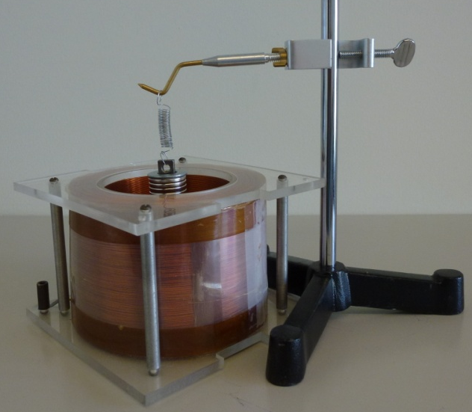
Question 3.2: Generator Demonstration
Another design for an electric generator is to have a magnet oscillate on a spring inside a multi-turn coil, as is shown to the right. This meets all the requirements for electricity generation, namely:
- A closed coil, and
- A changing magnetic field inside the closed coil (through the movement of the magnet inside the coil).

If you use an oscilloscope to measure the current induced in the coil, you would see the picture to the right.
Time
Generated Electrical Signal

As a group, discuss the reasons why the induced current has a sinusoidal characteristic? Recall, that Lenz’s law states

“The magnetic field that is induced, or created, by a magnet moving through a closed coil will always act in opposition to the change of the magnetic field due to the moving magnet.”

The sinusoidal characteristic of the induced current indicates that the current flows in one direction (i.e., is “positive”) and then turns around and flows in the opposite direction (i.e., is “negative”). This is the essence of the term alternating current (AC).
Why does this reversal happen? From Lenz’s law we can predict the direction of the induced current from how the magnetic field within the coil is changing. Consider the following cases:
- The magnet is entering the coil (the spring is being extended). This means that the magnetic field within the coil is becoming stronger. The induced current will flow in a direction to oppose this increase in the magnetic field (say this is the flow of “positive” current).
- The magnet is leaving the coil (the spring is contracting). This means that the magnetic field within the coil is now decreasing in strength. The induced current will now switch directions so that it produces its own magnetic field which will add to the field within the coil (it opposed the decrease). This means that the current is now flowing in the “negative” direction.

