

PHY131-style Practical Guide

University of Toronto, Physics Department

U of T Lab Practical 1

Forces, Motion and the Scientific Method

OAPT Toronto Conference Workshop

Apr 30, May 1 2010

Based on materials in the U of T Physics Practicals of PHY131 / PHY132, which are relevant to the Ontario Curriculum, Grades 11 and 12, Physics University Preparation, SPH3U / SPH4U.

Note that all U of T Physics Practicals Materials (excluding instructors manuals) are available for free at: http://faraday.physics.utoronto.ca/Practicals/ . Today you will be looking at a very small portion of the over 200 pages worth of materials available there.

Original Authors: David M. Harrison, Jason J.B. Harlow Latest revision: Apr. 29, 2010

How this Workshop Works
Imagine you are in your first year at U of T. You are taking one of the biggest physics courses, PHY132, which is required for all life sciences majors. The lectures are in convocation hall, but most of your learning actually happens in Practicals. Here is where you actually get to explore and get used to what you heard about in lectures, and discuss it with your peers in a friendly environment.

Every pod comes with a note-book. Please open it now, and write your name and the names of the other people sitting at your pod.

One person should be elected as the Note-taker and another person as the Facilitator. (In PHY131/132, the roles of Note-taker and Facilitator should change person every week.) The note-taker is in charge of making everything that is done is recorded in the notebook, and the facilitator is the person who keeps the group progressing in the right direction (i.e., toward productivity).

Equipment List
Item | Qty
2.2 meter Track, Pasco ME-9452 with End Stop, Pasco ME-9808. Approx. $800 Canadian each | 1
#24 Rubber Bands (4” long, 1/8” wide, 1/32” thick) | 4
Collision Cart, Pasco ME-9454. Low friction wheels, very durable. Approx $125 Canadian each. | 1
Cart pin | 1
6-inch string | 1
PASCO Fan Accessory with guard, Pasco ME-9491. 2 aluminum dummies shaped like AA batteries. Approx $89 Canadian each. | 1
AA batteries | 1 pack of 4
Small screwdriver for prying out batteries | 1
PASCO 1.0 N Metric Spring Scale, SE-8714. Approx $37 Canadian each. | 1
OHAUS 20 N Dial Spring Scale | 1
Motion Sensor II, Pasco CI-6742. Approx. $150 Canadian each. | 1
Economy Force Sensor, Pasco CI-6746. Approx. $200 Canadian each. | 1
DAQ board, made at U of T. | 1
Large Table Clamp, Pasco ME-9472 | 1
Tape measure | 1
Rod mounted vertically on the Table Clamp | 1
Bubble-level | 1

Mechanics Module 2 - Student Guide [Instructor Guide is separate]
This module is normally performed in weeks 3 and 4 of a 12-week semester of PHY131: Introduction to Physics.
Note: OAPT members can log into the computers with user name “student”, no password, log-on to “this Computer”

Mechanics Module 2, Activity 10: Introduction to the Motion Sensor
For this Activity you will be using a computer-based laboratory system with an ultrasonic motion sensor and motion software. The motion sensor acts like a stupid bat when hooked up with a computer-based laboratory system. It sends out a series of sound pulses that are too high frequency to hear. These pulses reflect from objects in the vicinity of the motion sensor and some of the sound energy returns to the sensor. The computer is able to record the time it takes for the reflected sound waves to return to the sensor and then, by knowing the speed of sound in air, figure out how far away the reflecting object is.

To start the motion sensor:
- double-click on the desktop folder; “Labview Files”
- double-click on the folder “MotionSensor”
- Double-click the “MotionSensor LabVIEW Instrument” icon

Set the switch on top of the sensor to the narrow beam, which on some sensors is indicated by an icon of a cart. Click “Start Detector”, and “Collect Data”, both of which are toggle switches which turn collection on and off.

Use the system to take position-time data of the cart as one of your Team moves it towards and away from the sensor. Try to glide the cart as smoothly as possible at constant speed.

The software will compute the average velocity and acceleration. Click the “Analyze” tab to see these plots. Does the plot of average velocity look smooth? If not, why? What about the plot of average acceleration? Does the slope of the velocity curve seem to match the value of the acceleration?

Mechanics Module 2, Activities 12, 13: What does “force” feel like?
In this Activity you will use a Force Sensor. When connected to appropriate software, this device measures forces exerted on it. The device uses a piezoelectric material, which generates a voltage proportional to the force exerted on it. Other uses of piezoelectrics include contact microphones, the motion sensor capabilities of the Sony Playstation 3 and Nintendo Wii controllers.

Pick out one of the Number 24 rubber bands as your standard rubber band. You may want to identify it by marking it with a pen or pencil. Loop the rubber band loose around your fingers as shown. Slowly separate your hands until the rubber band is not slack.

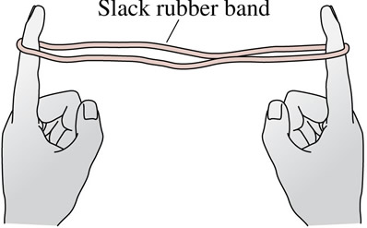
Now separate your hands by some further predetermined “standard” length that you choose. You can feel that the rubber band is exerting forces on both of your fingers. How do the magnitudes of these two forces compare?

Each member of your Team should do this simple little experiment.

To start the force sensor:
- double-click on the desktop folder; “Labview Files”
- double-click on the folder “ForceSensor”
- Double-click the “ForceSensor LabVIEW Instrument” icon
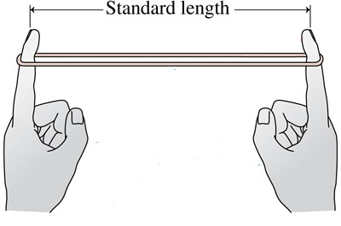
- Click “Acquire Data”, which acts as a toggle switch.

- When stretched by the standard length the rubber band is exerting a standard force on your fingers. Decide what name you wish to give to this standard force.
- Now loop the rubber band around the hook on the Force Sensor that is mounted on the vertical rod and start the Force Sensor program on the computer. Push the Tare button on the Force Sensor to zero its reading. Stretch the rubber band by the standard length and determine the force in newtons corresponding to your standard force.
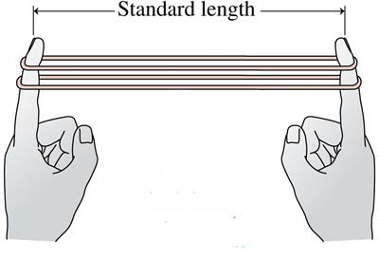
- Now loop two rubber bands around your fingers and stretch them by your standard length. How does the force exerted on your fingers with two rubber bands compare to just one?
- Repeat with three rubber bands.
- Use the Force Sensor to check your feelings about the magnitudes of the forces.

Mechanics Module 2, Activity 14: Kinematics of Constant Acceleration
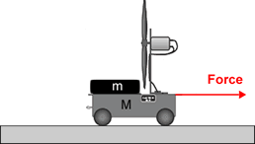
In this Activity you will use a Fan Accessory. The fan accessory clamps to the collision cart and produces an approximately constant force upon it.

- Avoid a runaway Cart falling off the Track.

Level the Track and leave the Motion Sensor mounted on one end. Warm up the bearings of the wheels of the Cart by rolling it up and down the Track a few times.

- Put 4 AA batteries in the Fan Accessory. Carefully clip the fan accessory to the top of the collision cart, avoiding putting too much pressure on the wheels of the cart. Place the Cart on the 2.2 m Track close to the Motion Sensor but at least 0.15 m away from it. You will want the direction of the air from the fan to blow towards the Motion Sensor. Turn the fan on and use the Motion Sensor to measure the acceleration of the Cart.
- Sketch a motion diagram of the Cart.
- Consider the Cart, motor, fan and the housing for the fan as the system under consideration. Sketch a Free Body Diagram of all the force acting on the system when the Cart was accelerating in Part A.
- Use the Force Sensor or a spring-scale to measure the horizontal force acting on the system by the fan when it is not moving. You may wish to loop a length of string over the small metal pin in the cart in order to attach the Force Sensor or spring-scale. Is this the force acting on the system when it is moving?
- Measure the mass of the cart, motor, fan and housing for the fan. There is a digital scale available at the front of the room.
- Use Newton’s 2nd Law with the force measured from Part D and the mass measured from Part E to predict the acceleration of the cart when the net force upon it is equal to the force provided by the fan. Compare this prediction to the measured acceleration in part A. Compare the prediction and measurement and discuss what might cause them to differ.

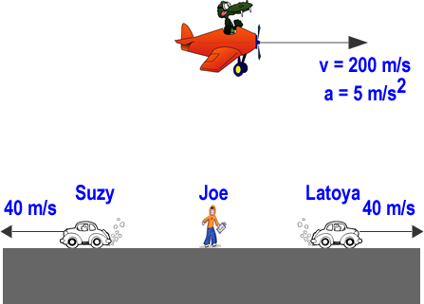
If You Have Time: Mechanics Module 2, Activity 8: Relative Velocity, and Relative Acceleration
Joe is stationary on the ground, and sees an airplane moving to the right with a speed of 200 m/s and accelerating at 5 m/s². Suzy is driving to the left at a constant 40 m/s and Latoya is driving to the right at a constant 40 m/s.
- Rank in order, from the largest to the smallest, the airplane’s speed according to Suzy, Joe, and Latoya at the moment shown in the figure. Explain.
- Rank in order, from the largest to the smallest, the magnitude of the airplane’s acceleration according to Suzy, Joe, and Latoya. Explain.

