
OAPT Conference 2007

at the

Ontario Science Centre

Accommodations List

Rates:

Rates shown were supplied by the hotels. Taxes are not included.

Please contact the hotel or B & B directly.

Room Sharing:

To find a possible room mate, consider posting a message on the OAPT Listserve.

Bed and Breakfast:

If you'd prefer a B & B, visit BBCanada.com for a comprehensive list of local B & Bs.

Hotels:

Crowne Plaza Toronto Don Valley details
Best Western Roehampton Hotel & Suites details
Howard Johnson Hotel Toronto-Markham details
Howard Johnson Hotel Toronto-East details

Other Hotels:

If you don't mind a longer commute, many other hotels are available. Click here.
Back to Hotel List

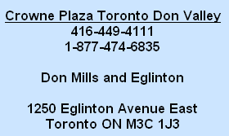
$129 per room per night

Crowne Plaza Toronto Don Valley

Be sure to ask for the Ontario Association of Physics Teachers rate!

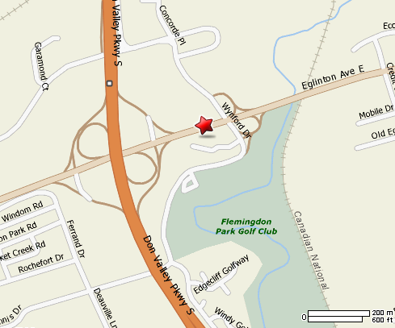

Directions:
From QEW/Gardiner (Downtown):
Take Don Valley Parkway North, Exit at Eglinton Avenue East, stay in the right hand lane, exits at Wynford Drive, turn right at the lights, and pass underneath the bridge, through the next set of lights, the Hotel's entrance is on the left.
From HWY 401:
Take Don Valley Parkway South to Wynford Drive exit, turn left (East) onto Wynford Drive, turn right at the next set of lights, the Hotel's entrance is on the right.
From Airport:
Follow 401 East to Don Valley Parkway. Travel south on Don Valley Parkway to Wynford Drive exit, turn left (East) onto Wynford Drive, turn right at the next set of lights, the Hotel's entrance is on the right.
Back to Hotel List
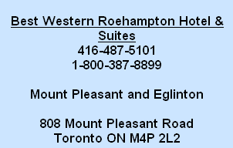
$119 per room per night until May 10

Best Western Roehampton Hotel & Suites

Be sure to ask for the Ontario Association of Physics Teachers rate!

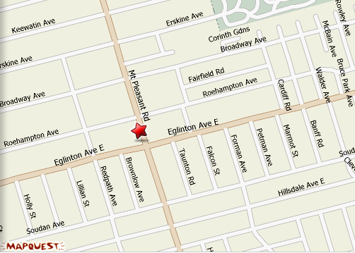

Directions:

From: The north. From Highway 401, exit south on Yonge Street. Turn left on Lawrence, then right on Mount Pleasant and continue to 808 Mount Pleasant Road, the Best Western Roehampton Hotel & Suites.

From: The south. From Lakeshore or Gardiner Expressway, follow Jarvis Street north. Turn right at the Mount Pleasant Road exit. Follow Mount Pleasant Road north to Eglinton Avenue. The Best Western Roehampton Hotel & Suites is located on the left, just north of Eglinton Avenue

From: The east. From Highway 401, westbound to exit south on Yonge Street. Turn left on Lawrence. Turn right on Mount Pleasant Road and continue to 808 Mount Pleasant, the Best Western Roehampton Hotel & Suites.

From: The west. From Highway 401, eastbound to exit south on Yonge Street. Turn left on Lawrence. Turn right on Mount Pleasant Road and continue to 808 Mount Pleasant, the Best Western Roehampton Hotel & Suites.
Back to Hotel List
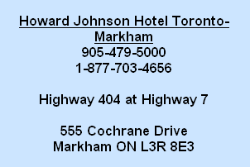
$79 until April 30
After that, rooms booked at that rate if available.
Howard Johnson Hotel Toronto-Markham

Be sure to ask for the Ontario Association of Physics Teachers rate!

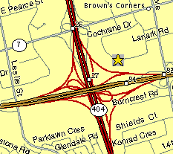

Driving Directions
Highway 401 East or West
Take Highway 404 North. Exit at Highway 7. Turn right (east) onto Highway 7 then turn right (south) on to East Valhalla Drive. Turn right onto Cochrane Drive.
Highway 407 (toll route)
Exit Woodbine Avenue North, turn left onto Lanark Drive. Turn left onto Cochrane Drive.
Highway 404
Exit at Highway 7 East and turn right on to East Valhalla Drive. Turn right onto Cochrane Drive.
Lester B. Pearson Airport
Take Highway 401 East - Exit to Highway 404 North. Exit at Highway 7. Travel East to East Valhalla Drive and turn right. Turn right onto Cochrane Drive.

Take Highway 427 North - Exit to Highway 407 East (Toll Route). Exit Woodbine Avenue North, turn left onto Lanark Drive. Turn left onto Cochrane Drive.
Back to Hotel List

Howard Johnson Hotel Toronto-East

Toll Free : 1-800-714-7496

Toronto : 416-293-8171
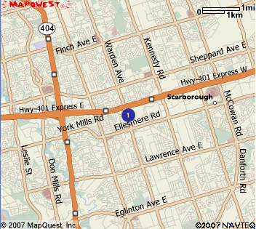

Driving Directions
- Take Don Valley Parkway (N)

- Take 401 East

- Exit on Warden South
Take first left on Metropolitan Road

